“Pochva”: a new hydro-thermal process model in soil, snow, vegetation for application in atmosphere numerical models

Abstract
This work presents the land model “Pochva”. “Pochva” is a model of hydro-thermal processes at the Earth surface and in the underlying medium. The model simulates the main hydro-thermal parameters of the surface, soil layer, vegetation and snow layer. Its soil process scheme allows to use physical parameters having vertical variations along the soil profile. Its snow processes scheme is a multiple layer scheme and has a numerical algorithm allowing to solve both cases of extremely thin and extremely thick layer. The model is marked by a particular accuracy in simulating the water phase transitions in soil and snow, and by the autonomy in the determination of the lower boundary condition in the soil column. The model can be used as a stand alone land-surface model driven by observed or analytical forcing data, or coupled to an atmospheric model, either global or limited-area, either in forecast regime or climatic (hindcast) regime. The results of coupling “Pochva” to the numerical weather prediction limited-area model “Bolam” are presented in this article.

1 Introduction

Water mass balance and energy balance at the Earth surface are key processes in a numerical model of the atmosphere. These processes determine the condition at the lower boundary for the main atmospheric parameters as well as air parameters in the surface layer. The surface hydro-thermal conditions are simulated by a scheme (or model) of hydro-thermal processes in the surface and in the underlying media, composed by soil layer, possibly covered by vegetation, and by snow layer.
The simulation of hydro-thermal processes in the underlying media in the current model is significantly evolved from a simple soil scheme (e.g. Deardorff, 1978) through to complex vegetation structures with multiple layer soil hydrology and energy and multiple layer snow. Examples of currently used land surface schemes include the Interaction Soil-Biosphere-Atmosphere model (ISBA, Noilhan and Planton, 1989); the Canadian Land Surface Scheme (CLASS, Verseghy, 1991; Verseghy et al., 1993); the Tiled ECMWF Scheme for Surface Exchanges over Land model (TESSEL, Viterbo and Beljaars, 1995), including multi-layer snow scheme (Arduini et al., 2019), the NOAH model (Ek et al., 2003); the Common Land Model of National Center of Atmospheric Research (USA) (Dai et al., 2003); the Community Land Model (CLM, Oleson et al., 2010), Joint UK Land Environment Simulator (JULES, Best et al., 2011), GEOtop (S. Endrizzi et al., 2014). The important role of a correct simulation of the interaction between the atmosphere and the land surface for current atmospheric and climatic research is discussed in a clear and complete manner in (Santanello et al., 2018).
The high number and variety of existing models is due to the fact that different models underline different processes in soil and vegetation. The differences are connected to the different purposes of their application: weather prediction, study of atmospheric processes, simulation of snow cover and avalanche prediction, climatic simulations coupled with biosphere models. Some models pay particular attention to hydro-thermal exchange processes in soil, take into account phase transition processes in soil water, and processes in the snow layer, they accurately describe the fluxes at soil surface. These models are more suitable for application in modelling of atmospheric processes and weather forecast. Other models pay more attention to an accurate description of the processes connected to vegetation, distinguishing high and low vegetation, simulating in detail processes like evapotranspiration and giving an accurate simulation of carbon cycle. These models are more addressed to climate and Earth system modelling.
The model proposed in the present work is closer to the first class of models, i.e. is more suitable for models targeted at the study of atmospheric process and weather prediction models. In the proposed model, special attention was paid to the accuracy of description of heat and moisture exchange in soil, including water phase transitions, to the accuracy and reliability in the description of processes in the snow layer, including water melting and re-freezing, to the inhomogeneity soil parameters along the vertical, to the definition of thermal and hydraulic conductivity in the different situations, to the problem of defining the atmospheric humidity at the contact surface with the soil and vegetation leaves, to the problem of determining the albedo and density of snow cover depending on its history. In the proposed model an original method for defining bottom boundary conditions for temperature and humidity is applied, making the model autonomous in the frame of a known climatology or climatological drift. The model can also be useful for the simulation of snow cover for avalanche prediction purposes since the snow module is independent of the other modules and applied separately. The model can also be used with a forcing derived from observational data for defining the fluxes between the surface and the atmosphere as well as for idealised column simulations.
The present paper is divided into eight sections, the second, third, fourth, fifth and sixth are devoted to the description of the schemes included in the model: surface processes, processes in the vegetation, heat exchange processes in the soil, moisture exchange processes in the soil, processes in the snow layer. The seventh section contains the description of the numerical experiments and their results. The last section contains the conclusions and some discussion about the critical points of the model and of the verification results.

2 Surface processes scheme

The interaction between the atmosphere and the Earth surface from the point of view of atmospheric modelling, takes place mainly by means of fluxes of heat and moisture. The main parameter describing the thermal state of the soil environment in the present model is the entropy. This variable has been chosen since it simplifies the description of the water phase changes.
The state of the atmosphere interacting with the Earth surface is described by air temperature, specific humidity and pressure at the lowest atmospheric level, turbulent transfer coefficients between surface and lowest atmospheric level, total net radiation flux, fluxes of atmospheric precipitation in liquid and crystal phases. The state of the surface with regard to atmospheric dynamics equations, is described by temperature and specific humidity of the air. The values of these two parameters depend on the whole state of the underlying surface.

2.1 State of the soil surface
According to the principles adopted in this work, a unit size of underlying surface is composed by a set of fractions each having uniform characteristics from the point of view of the interaction with the atmosphere. The soil surface can be covered by vegetation (grass, shrub), high vegetation (trees, woodland) and snow. Snow cover and high vegetation imply the presence of a particular layer with its own thermodynamic characteristics, thus with a distinct temperature. For this reason, it is not possible to consider them as a fraction of the surface of the soil itself, but it is necessary to consider them as independent “columns”. As a consequence, if we introduce the concept of fraction of snow cover, it is necessary to divide the surface into three independent columns, each having its own temperature even in case of equal upper and lower boundary conditions. In the present version of the model here described, however, the following simplifying assumptions have been made: the vegetation has not been divided into high and low and the two types, possibly mixed, are considered as a part of the soil surface with particular characteristics; the snow layer can either cover all the surface or not exist at all, a fractional snow cover is introduced only as a diagnostic field to allow computation of the radiative characteristics of the surface (albedo, emissivity). Under this assumption, the soil surface can either consist of bare soil possibly partly covered by low vegetation, which in turn may be partly covered by water, or consist of snow cover. These two states of the surface can turn one into the other but cannot exist simultaneously.
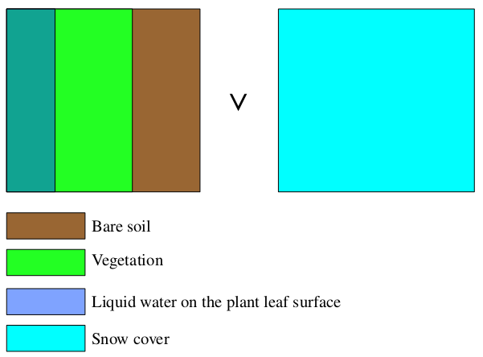
Fig 1. Scheme of the soil surface.

In the area of a single model grid cell the vegetation fraction and the fraction of low-vegetation leaves covered by water are given.
In this way, the surface interacting with atmosphere can be of the following types:
- without snow cover (F_{snow}=0):
1) bare soil
2) low-vegetation leaves not covered by water
3) low-vegetation leaves covered by water
- in case of snow cover, under the indicated assumptions the only type of interacting surface is:
4) F_{snow}=1
More precisely, in presence of snow, we always assume F_{snow}=1 for the computation of moisture fluxes, while for the entropy fluxes, F_{snow}=1 holds only if the snow cover has a minimal thickness, otherwise, for a shallow snow layer, entropy fluxes are computed under the assumption of F_{snow}=0 (see the explanation of the snow scheme for more details).
For each of these four surface types, surface air temperature and humidity have to be defined. The overall surface air temperature and humidity for the whole grid cell are then computed as an average of these values weighted with the fractional area of each surface type.

2.2 Air temperature and humidity on bare soil
For bare soil, the surface air temperature (T_{surf soil}) is equal to the temperature of the upper soil layer (T_{soil0}). The air specific humidity q_{v} _{surf soil} (kg kg⁻¹) is defined according to the diagnostic expression
, (1)
where: q_{v} _{atm} is the air specific humidity at the lowest atmospheric level (kg kg⁻¹), q_{v} _{sat}(T_{soil0}) is the saturation air specific humidity at temperature T_{soil0} computed as:
, (2)
where, in turn, q_{v sat}^{water} and q_{v sat}^{ice} are saturation air specific humidity over liquid water and ice respectively, α_{soil} is an empirical coefficient.
For the definition of the empirical coefficient α_{soil} an original method is proposed in this work. The approach proposed has been formulated after many numerical experiments and statistical verification on a big number of observational meteorological stations (see section 6). The definition is the following:
, (3)
where:
K^{turb}_{v} is the coefficient of water vapour exchange in the surface layer (m² s⁻¹),
F₁^{soil} and F₂^{soil} are empirical functions of the relative moisture contents of the upper soil layer:
, (4)
, (5)
where b is the so-called «soil exponent» (Clapp and Hornberger, 1978), q^{rel}₀ is soil relative water content at the top level (see section 4). The choice of the values defining the empirical function is crucial since it strongly influences the magnitude of the water vapour flux and its associated latent heat flux, which, in turn, influences the soil surface temperature and the air temperature at 2 meters routinely used for the verification of numerical weather predictions. The methodology used for defining these empirical coefficients and their influence on the numerical weather forecast will be treated in a separate publication dedicated to the evaluation of the numerical model results.

2.3 Air temperature and humidity over vegetation with leaves not covered by water
The air temperature in this case (T_{veg}^{dry}) is equal to the temperature of the topmost soil layer (T_{soil0}). For the definition of air humidity two cases are distinguished: the evapotranspiration is active or is not active. The conditions under which evapotranspiration is or is not active are shown in section 3.
In the case of lack of evapotranspiration, the air humidity is equal to the air humidity at the lowest atmospheric layer while in the case of active evapotranspiration by leaves not covered by water it is defined analogously to the case of bare soil:
, (6)
where:
q_{v} _{veg}^{dry} is the air specific humidity over respiring plant leaf,
q_{v} _{atm} is air specific humidity at the bottom atmospheric level (kg kg⁻¹),
q_{v} _{sat}(T_{soil0}) is saturation air specific humidity (kg kg⁻¹) at soil surface temperature T_{soil0}, (see paragraph 2.2),
α_{veg} is an empirical parameter depending the magnitude of the evapotranspiration activity,
β_{veg} is a parameter depending on the moisture content in the root layer of the soil.
The parameter defining the evapotranspiration activity is given by:
, (7)
where F₁^{veg} and F₂^{veg} are empirical functions depending on the turbulent exchange coefficients for water vapour in the atmospheric surface layer and on the intensity of the evapotranspiration process which in turn depends on the flux of visible solar radiation and on LAI (Leaf Area Index) according to:
, (8)
, (9)
where:
F_{vis rad} is the flux of visible solar radiation at the surface (Watt m⁻²),
LAI_{max} is the maximum value of LAI in the static global database used.
In order to evaluate the parameter β_{veg}, a description of the finite-difference representation of the vertical space coordinate used in the model is described here.
As a vertical coordinate, the geometrical length (depth) is used, with the origin at the surface and values growing with growing depth. The vertical computational domain is divided into full and half levels, with the upper full level having index zero, and with each half level having the same index as the full level located below it; the level indexes grow with growing depth (see fig. 2).

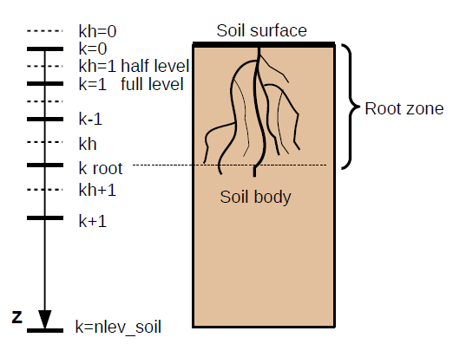
Fig. 2. Finite-difference discretisation of the vertical coordinate in the soil.
The upper part of the soil column may contain plant roots. The depth of the root layer is defined as
, (10)
Where z (m) is the space coordinate in soil, k is the index of full level in the vertical discretization, k_{root} is the index of the deepest root zone level.
, (11)

, (12)
, , , (13)
where
q _{k} and q _{k}^{rel} are the soil specific volumetric (m³ m⁻³) and relative (proportion) water content at level k,
q _{k}^{max} and q _{k}^{min} are the maximum and minimum soil specific volumetric contents at level k (m³ m⁻³),
q_{k}^{wilt} and q_{k}^{rel} ^{wilt} are soil specific volumetric (m³ m⁻³) and relative (proportion) water contents at level k at wilting point, i.e. at the water content at which plant evapotranspiration stops because of too dry soil,
q_{k} ^{ref} and q_{k}^{rel} ^{ref} are soil specific volumetric (m³ m⁻³) and relative (proportion) water contents at level k at «reference point», i.e. at the water content level at which plant evapotraspiration stops increasing because of highly wet soil.

2.4 Air temperature and humidity over vegetation with leaves covered by water

The air temperature in this case (T_{veg}^{wet}) is equal to the temperature of the topmost soil layer (T_{soil0}). The air humidity is equal to the saturation humidity at the given temperature:
, (14)
where q_{v} _{sat}(T_{soil0}) is the saturation air specific humidity (kg kg⁻¹) at soil surface temperature T_{soil0} (see paragraph 2.2).

2.5 Air temperature and humidity over snow cover

The air temperature in this case (T_{surf snow}) is equal to the temperature of the topmost snow layer (T_{snow0}). The air humidity is equal to the saturation humidity at the given temperature:
, (15)
where q_{v} _{sat}(T_{snow0}) is the saturation air specific humidity (kg kg⁻¹) at snow cover surface temperature T_{snow0}.
, (16)
where q_{v sat}^{water} and q_{v sat}^{ice} are saturation air specific humidity (kg kg⁻¹) at snow cover surface temperature T_{snow0} over liquid water and over ice respectively.

2.6 Air temperature and humidity over a composite soil surface

Having defined the values of air temperature and humidity over all the possible components of a composite soil surface, and knowing the fraction of each component of the surface, it is possible to define the overall surface air temperature (T_{surf}) and humidity (q_{v surf}).
In absence of snow cover, or in presence of a so-called shallow snow layer (see the description of snow scheme) the overall surface air temperature is equal to the weighted mean of the temperatures of the surface components:
, (17)
while in case of a thick snow layer we have:
. (18)
Similar formulas hold for the surface specific humidity, in case of absence of snow cover:
, (19)
and in presence of snow cover (either thick or shallow):
. (20)

2.7 Entropy flux between soil surface and atmosphere

The surface incoming entropy flux is composed by the turbulent flux of entropy for dry air, the turbulent flux of entropy due to water vapour and the entropy flux due to the global radiation:
, (21)
where:
Φ_{S surf} is the surface entropy flux (J K⁻¹ m⁻² s⁻¹),
Φ_{S da}^{turb} and Φ_{S v}^{turb} are the entropy fluxes originating from turbulent entropy flux of dry air and of water vapour (J K⁻¹ m⁻² s⁻¹),
Φ_{S rad} is the entropy flux originating from global radiation (J K⁻¹ m⁻² s⁻¹).
The flux of entropy due to the flux of water (in liquid and solid phases) from atmospheric precipitation is neglected since in the soil entropy scheme the entropy flux originating from soil moisture flux is also neglected.
The entropy fluxes are computed according to the following relations:
, (22)
where Φ_{rad} is the flux of global radiation (Watt m⁻²).
, (23)
where:
K_{h}^{turb} is the coefficient of heat exchange in the surface layer (m² s⁻¹),
ρ_{a surf} is the air density at the surface (kg m⁻³),
z_{atm} is the height of the lowest atmospheric level (m).
S_{da surf} and S_{da atm} are specific entropy of dry air on the surface and at the lowest atmospheric level (J kg⁻¹ K⁻¹).
The entropy of dry air is defined by the relation:
: (24)
where:
S_{da} is the specific entropy of dry air (J kg⁻¹ K⁻¹),
q_{d} is the specific mass of dry air (kg kg⁻¹),
T is the temperature (K),
P_{d} is the partial pressure of dry air (Pa),
T₀=273.15 К is the reference temperature,
P₀=10⁵ Pa is the reference pressure,
C_{p}^{d}=1004.6 J kg⁻¹ K⁻¹ is the specific heat capacity of dry air at constant pressure,
R_{d}=287.05 J kg⁻¹ K⁻¹ is the gas constant of dry air.
In order to define the entropy of dry air at the surface and at the lowest atmospheric level, the known values of air temperature, humidity and pressure are used together with the relations:
, (25)
, (26)
, (27)
, (28)
q_{da surf} and q _{da atm} are dry air specific mass at the surface and at the lowest atmospheric level (kg kg⁻¹),
P_{d surf} and P_{d atm} are partial pressure of dry air at the surface and at the lowest atmospheric level (Pa),
e _{surf} and e_{atm} are partial pressure of water vapour at the surface and at the lowest atmospheric level (Pa).

The entropy flux of water vapour originating from turbulent exchange in the layer between soil surface and lowest atmospheric level is defined as:
, (29)
where S_{v surf} and S_{v atm} are specific entropy of water vapour at the surface and at the lowest atmospheric level respectively (J kg⁻¹ K⁻¹), which, in turn, are defined by:
(30)
where:
S_{v} is the specific entropy of water vapour(J kg⁻¹ K⁻¹),
q_{v} is the air specific humidity (kg kg⁻¹),
e is the partial pressure of water vapour (Pa),
e₀=611 Pa is the reference partial pressure of water vapour,
C_{p}^{v}=1869.46 J kg⁻¹ K⁻¹ is the specific heat of water vapour at constant pressure,
R_{v}=461.51 J kg⁻¹ K⁻¹ is the gas constant for water vapour,
L_{i}^{v}=2834170.5 J kg⁻¹ is the specific latent heat for ice-vapour phase transition.

The total entropy flux between atmosphere and soil surface (Φ_{S surf}) determined in this way has to be assigned to each component of the complex soil surface in order to define the boundary condition for each type of surface. As introduced in section 2.1, the surface can either be composed by soil partially covered by low vegetation, or by snow, which, in turn, may be “thick” or “shallow”. From the point of view of entropy (energy) exchange, low vegetation behaves as a “transparent” layer, i.e. it does not have an own temperature and it is part of the soil surface thus it does not have its own entropy flux. Thus, two cases may be realised.
The first case is realised when snow cover is absent or shallow. In this case all the components of the flux fully impinge on the soil surface with low vegetation and snow surface does not receive any flux:
,
.
The second case is realised when snow layer is present and thick. In this case all the entropy flux impinges on the snow surface and the soil surface does not receive any direct flux:
,
.

2.8 Water vapour flux between soil and atmosphere

The flux of water vapour originating by means of turbulent exchange between surface and atmosphere is defined as:
, (31)
where Φ _{v} ^{turb} is the flux of water vapour in the atmosphere surface layer (kg m⁻² s⁻¹).
This summary flux has to be split between the components of the soil surface.
In the absence of snow cover, the water vapour exchange takes place between atmosphere and soil surface covered by (partly wet) vegetation. Two cases can be distinguished: in the first case the flux is positive (i.e. downwards) thus condensation (deposition) of water vapour on the surface takes place; in the second case the flux is negative (i.e. upwards) thus evaporation (sublimation) from the surface takes place.
When the flux is directed downwards, it partly impinges on the bare soil surface and partly on the vegetation, where it contributes to the formation of dew over the leaves up to a maximum pre-specified value of water content as in the formulas:
, (32)
, (33)
, (34)
where:
Φ _{v} ^{turb}_{soil} is the flux of water vapour in the atmospheric surface layer towards bare soil (kg m⁻² s⁻¹),
Φ _{v} ^{turb}_{veg dry} and Φ _{v} ^{turb}_{veg wet} are the fluxes of water vapour in the atmospheric surface layer towards not moistened and moistened vegetation (kg m⁻² s⁻¹),
q_{w veg} and q_{w veg}^{max} are the water contents of plant leaves and its maximum value (kg m⁻²) respectively,
Δt is the model time step (s).
When the flux is directed upwards, it removes water partly from the bare soil surface, partly from the soil through plant evapotranspiration and partly through evaporation of water on the leaves. When conditions for evapotranspiration are not met the corresponding flux is zero (see description of vegetation scheme), while evaporation from leaves obviously takes place as long as there is water available on leaves surface, as in the following formulas:
, (35)
, (36)
. (37)
In the presence of snow cover, the water vapour fluxes between atmosphere and bare soil/vegetation are null and the interaction takes place only between atmosphere and snow layer:
, (38)
where Φ _{v} ^{turb}_{snow} is the flux of water vapour in the atmosphere surface layer towards snow layer (kg m⁻² s⁻¹).

2.9 Atmospheric precipitation flux at the surface

Atmospheric precipitation flux over surface, divided into liquid (Φ_{w}^{liq}) and solid (Φ_{w}^{ice}), is provided by the atmospheric model. The distribution of these fluxes over the soil surface depends on the presence of snow over it.
In absence of snow cover, liquid precipitation contributes to the surface components, including leaves, according to the fraction of each component; the amount of water on leaves exceeding the maximum allowable is immediately redistributed among the bare soil components:
, (39)
, (40)
, (41)
where Φ_{w}^{liq}, Φ_{w}^{liq}_{soil}, Φ_{w}^{liq}_{veg}, Φ_{w}^{liq}_{snow} are the fluxes of atmospheric precipitation in liquid phase on the whole surface, on the soil surface, on vegetation and on the snow-covered surface respectively (kg m⁻² s⁻¹).
In presence of snow cover, all the liquid precipitation flux is directed to the snow layer:
, (42)
. (43)
Conversely, solid precipitation flux is always directed to snow layer, creating it if it does not exist:
, (44)
. (45)
where Φ_{w}^{ice}, Φ_{w}^{ice}_{snow}, Φ_{w}^{ice}_{soil}, Φ_{w}^{ice}_{veg} are the fluxes of atmospheric precipitation in solid phase on the whole surface, on the snow-covered surface, on the snow-free soil surface and on vegetation respectively (kg m⁻² s⁻¹).
The surface processes scheme defines the conditions on the upper layer of the soil column in absence of snow cover or on the snow column in presence of snow. The boundary conditions are given by fluxes of entropy and water which can consist of water vapour and precipitation. The soil scheme can also define the air temperature and humidity over a composite surface.

3 Scheme of vegetation processes

In the vegetation scheme two processes are represented: evapotranspiration and interception of water by plant leaves.
Considering evapotranspiration process, we recall that in the previous section the water vapour flux between soil surface and the lowest atmospheric model was defined taking into account evapotranspiration of plants (Φ_{v}^{turb}_{veg dry}, 33, 35). In this section the conditions under which evapotranspiration can take place are defined, as well as the change in soil wetness due to evapotranspiration.
Evapotranspiration is possible when the following conditions are fulfilled:
- in each level of the plant root zone the temperature is above 0°C;
- the air saturation specific humidity at surface temperature is higher then the actual air specific humidity at the lowest atmospheric layer, i.e. the water vapour flux can be directed upwards;
- leaves are present, i.e. Leaf Area Index (LAI) is nonzero;
- photosynthesis is possible, i.e. the incoming visible radiation flux is positive.
The water vapor flux due to evapotranspiration from leaf surface not covered by water (Φ _{v} ^{turb}_{veg dry}, see paragraph 2.9) removes water from the root zone of soil and each layer of this zone loses water proportionally to its contribution to evapotranspiration flux. In paragraph 2.3 it was shown how to determine air humidity over a vegetation surface not covered by water depending on the evapotranspiration rate (6) and the scheme of vertical space discretisation in soil was presented (fig. 2).
Consequently, the contribution of each root-zone level to the overall water flux due to evapotranspiration becomes:
(46)
and the wetness variation in each soil level due to evapotranspiration is:
, (47)
where ρ_{w} is the liquid water density (kg m⁻³).
Considering, on the other hand, interception by vegetation leaves, the water content over low-vegetation leaves is determined by the turbulent flux of water vapor between the leaves and the lowest atmospheric level (Φ _{v} ^{turb}_{veg wet}), thanks to which either evaporation (sublimation) or condensation (deposition) can take place, as well as by atmospheric liquid precipitation flux over vegetation surface (Φ_{w}^{liq}_{veg}). Thus the prognostic equation for the water deposited over leaves looks like:
, (48)
where q^{Δt}_{w} _{veg} and q⁰_{w} _{veg} are the water contents on plant leaves at the beginning and at the end of the time step (kg m⁻²), while the other variables were defined at paragraphs 2.9 and 2.10.
The water intercepted by vegetation leaves can cover the leaves either partially or completely, as mentioned in paragraph 2.1, where the concept of leaf fraction covered by water (F_{veg}^{leaf wet}) was introduced. This fraction is determined by the diagnostic relation:
, (49)
where the exponent 2/3 is needed to evaluate the cross-section ratio from the volume ratio for a spherical drop.
The vegetation scheme thus defines the variation of water content in the root zone due to evapotranspiration and to water intercepted by leaves and provides a diagnostic relation for the leaf fraction covered by water.

4 Scheme of water exchange processes in the soil

The main equation describing dynamics of liquid water along the soil profile is the Darcy’s law:
, (50)
where Φ _{f} is the fluid flux (m s⁻¹), ∇P is pressure gradient (Pa m⁻¹), μ is the fluid viscosity (Pa s), Ω is the section area (m²). When applied to the transport of water in soil, Darcy’s law takes the form:
, (51)
where Ψ is the hydraulic head or hydraulic potential (m), W_{s} is the ratio of drained water volume at saturation to the total material volume (m³m⁻³) or maximum specific volumetric water content , Κ is the hydraulic conductivity (m s⁻¹), G represents the water source terms (m³m⁻³s⁻¹ ), t is time (s).
Assuming the absence of water sources, in the hypothesis of constant Κ and considering only the vertical coordinate, the equation can be written as:
. (52)
In the usual “soil notation” this equation is written as:
, (53)
where , Φ _{w} is the soil water flux (kg m⁻² s⁻¹), q_{max} is the maximum specific volumetric water content (m³m⁻³), i.e. in the case when all the soil pores are filled with water; this parameter depends on the soil texture and changes along the profile depending on soil horizon.
The equation introduced here operates on soil hydraulic potential, while the main prognostic quantity for soil moisture is q, i.e. the specific volumetric moisture content (m³m⁻³), so it is necessary to express Ψ in terms of q.
Using the method of Clapp and Hornberger (1978) and introducing the concept of partially frozen soil moisture, the hydraulic potential can be represented as:
, (54)
where Ψ_{g} is the hydraulic potential of saturated soil (i.e. when q=q_{max}), b is an empirical parameter named “soil exponent”, both these parameters depend on soil texture and can change along the soil profile depending on soil horizon, f_{ice}^{soil} is the fraction of frozen water with respect to total soil water. It can be noticed that formula (54) is valid only when f_{ice}^{soil}<1 since in case of total freezing of water in soil the hydraulic potential tends to infinity and no moisture motion can take place.
An important component of (53) is the hydraulic conductivity of soil which depends on its physical properties and on soil water content itself. Using again the Clapp and Hornberger (1978) method and extending it to the case of partly frozen soil moisture, the dependence of hydraulic conductivity on water content takes the form:
, (55)
where K_{g} is the hydraulic conductivity of saturated soil (when q=q_{max}), also depending on soil texture.
By substituting equation (54) into equation (53) under the assumption that the fraction of frozen water does not change during the process, i.e. , a prognostic equation for q is obtained, describing the motion of moisture along the soil profile:
. (56)
In a finite difference representation, (see fig. 2), applying an explicit approximation of the moisture flux terms and of the space derivatives, equation (56) takes the form:
, (57)
, (58)
where the upper indexes 0 and Δt indicate the variables at the beginning and at the end of the time step respectively, while the lower indexes k and kh indicate the values of variables taken at full and half vertical levels respectively (fig. 2).
The values of the variables at half levels are computed as arithmetical means:
.
In the case when a soil layer is completely frozen, f_{ice}^{soil}=1, the hydraulic potential tends to infinity, so the moisture flux is simply set to 0, i.e. if f_{ice}^{soil}=1 or f_{ice k-1}=1, then Φ⁰_{wkh}=0.

5 Scheme of thermal exchange processes in the soil

As stated in section 2, the quantity describing the thermal state of the environment in the present model has been chosen to be the entropy. The use of this quantity allows to describe phase changes of water in soil in a simple mathematical form, while it does not significantly differ from other thermodynamical quantities in the description of thermal exchange. In the present model two main approximations are applied in the numerical solution scheme. The first is the application of the splitting method for solving the prognostic equation for entropy, i.e. the equation for the conductive transport of entropy is solved separately from the equation for entropy conservation in moist soil in case of phase change of soil water. The second approximation consists in neglecting the entropy due to water fluxes in the equation for the conductive transport of entropy. These approximations are applied on the base of the experience in numerically solving the given problem. Due to the application of different space and time approximations, problems generated by small numerical inaccuracies (differences of big numbers) appeared, leading to an unacceptable instability and unphysical solution in particular situations. The aforementioned approximations mitigated these instabilities.

Let’s first consider the first part of the problem, i.e. the conductive transport of entropy in humid soil. This process is described by the diffusion equation in the form:
, (59)
where S_{soi} is the soil entropy (J K⁻¹ m⁻³), Φ_{S soil} is the soil entropy flux (J K⁻¹ m⁻² s⁻¹).
The entropy of humid soil is a function of the specific entropy:
, (60)
, (61)
where S_{soil}^{spec} is the specific entropy of humid soil (J kg⁻¹ K⁻¹), ρ_{soil} is the density of humid soil (kg m⁻³), C_{soil} is the specific heat capacity of humid soil (J kg⁻¹ K⁻¹), T is the soil temperature (K).
The conductive flux of entropy is defined as:
, (62)
where λ_{soil} is the specific heat conductivity of humid soil (J s⁻¹ m⁻¹ K⁻¹).
From the thermodynamical point of view, humid soil includes two components: dry soil, which does not undergo phase changes, and water, which undergoes phase changes and can be represented as a mixture of water and ice (the gaseous phase of water in soil is neglected). For this reason, the following assumptions are made in relation to the parameters of humid soil:
, (63)
, (64)
where ρ_{soil}^{dry} is the density of dry soil (kg m⁻³), C_{soil}^{dry} is the specific heat capacity of dry soil (J kg⁻¹ K⁻¹), both quantities depending on the soil characteristics (texture) and varying along the vertical, ρ_{w} and ρ_{i} are density of liquid water (1000 kg m⁻³) and ice (900 kg m⁻³), C_{w} and C_{i} are specific heat capacity of liquid water (4186.8 J kg⁻¹ K⁻¹) and ice (2093.4 J kg⁻¹ K⁻¹), q is the soil specific volumetric water content (m³ m⁻³) and f_{ice}^{soil} is the fraction of frozen water in total soil water, introduced in previous chapters.
Defining the value of the specific heat conductivity of moist soil is by itself a non-obvious problem. The main factor influencing this quantity is the moisture content of the soil. Different approaches for defining soil heat conductivity depending on its moisture content are known in literature, for example through hydraulic potential (Pielke, 2013) or through relative water content and heat conductivity of dry and saturated soil (Peters-Lidard et al., 1998, Best at al., 2011). In the present work a different approach is proposed. i.e. by means of relative water content and soil density:
, (65)
where q^{rel} is the soil relative water content, as in (13) and λ_{i} is the specific heat conductivity of ice (2.0 J s⁻¹ m⁻¹ K⁻¹).
The proposed definition and the proposed values for the coefficients were formulated during the numerical experiments and verification of air temperature shown in section 9. The definition of this quantity significantly influences near-surface temperatures, especially daily minimum and maximum values and amplitude of diurnal cycle, in the cases of stable boundary layer. The experiments showed that the given formula is suitable for different types of soil encountered in the territories of Europe and Western Asia.
Considering now the second part of the problem, i.e. the conservation of entropy of soil moisture in case of phase change, the quantity which has to be conserved is the sum of liquid water and ice entropy:
, (66)
where S_{soil}^{water} is the entropy of soil water (J K⁻¹ m⁻³), L_{i}^{w} is the specific latent heat of ice-water phase change (333560.5 J kg⁻¹).
In the equation for the conductive transport of entropy the phase changes of water are not considered, i.e. the fraction of ice in total soil water (f_{ice}^{soil}) is assumed to be known and the only unknown is the temperature. In the equation describing the phase changes of soil water (66) two unknowns are present, temperature and fraction of ice in soil water, so that, in order to solve this equation an additional equation relating the two quantities has to be added. This equation is introduced on the base of the hypotheses that at temperatures over 0 ºС the fraction of ice is equal to zero, while at temperatures below a certain threshold (here -30 ºС is assumed) the water in liquid phase cannot exist thus the fraction is equal to one. Between these two threshold values the fraction of ice grows monotonically with decreasing temperature and the shape of growth is assumed to be a hyperbolic tangent:
, (67)
where the empirical coefficient defines the thermodynamic regime and does not depend on the soil characteristics, while the coefficient f_{b} depends on the soil characteristics and can assume values in the interval 1 ≤ f_{b} ≤ 2:
, (68)
where b is the soil exponent already introduced in previous sections, the higher the value of b, the smoother the growth of the ice fraction with decreasing temperature.
Let’s now consider the numerical solution of the split problem: the discretisation of the vertical coordinate is the one shown in section 2 (fig.2), while a time-explicit approximation of fluxes and of their derivatives, is used; the equation for conductive transport of entropy (59) thus becomes, in finite-difference form:
, (69)
where indexes k and kh indicate values on vertical full and half levels respectively, the upper indexes o and * indicate values of temperature before and after the solution of the conductive transport equation respectively. The values of the physical parameters on half levels are computed as the arithmetical mean of the values on the full levels. In order to compute the density and the heat capacity of wet soil, the value of soil ice fraction computed at the beginning of the step is used.
The solution of (69) allows to compute the temperature T* taking into account the contribution of conductive heat flux but without taking into account any possible phase change.
After solving the first part of the split problem, the value of temperature T* obtained allows to compute the entropy of soil water, which is being considered its final value at the end of the time step:
, (70)
where q_{k} and f_{ice k}^{soil 0} are the total moisture content and soil ice fraction on the level k, before taking into account the phase changes.
The value of soil water entropy obtained is then used for computing the temperature and ice fraction at the end of the time step, i.e. after considering the possible phase changes, by solving the equation system:
, (71)
where T_{k}^{Δt} and f_{ice k}^{soil Δt} are the values of temperature and ice fraction on level k at the end of the time step. The system (71) is solved by successive iterations, which is an effective method in this case since functions (66) and (68) are smooth and monotonous.
It has to be noted that, in the presence of a thin layer of snow over the soil surface, for which it is not convenient, from the point of view of numerical precision, to solve a separate equation for conductive transport and phase change, the entropy of soil moisture on the upper soil layer is increased by the value of entropy of the thin snow layer (see next section for more details). The resulting temperature value is valid both for the soil surface and for the snow layer.

6 Snow scheme

The processes of formation, transformation and melting of snow over the soil surface are very important since they are connected with water phase changes, i.e. with a powerful energy source or sink, and with an important thermal insulating layer between atmosphere and soil. In this work an original multi-layer scheme for the evolution of snow cover is proposed.
As it was shown in section 2, from the point of view of thermodynamic processes, the snow layer may either cover the entire surface or be completely absent. However, a concept of minimal snow thickness is introduced, above which the snow can be considered as a separate layer from the point of view of heat transport and phase changes. If the snow layer thickness is smaller than this minimum value, the snow is considered as an additional component of the soil surface (section 5). At the same time, when considering water balance, i.e. processes related to atmospheric precipitation and water vapour condensation and sublimation, the snow layer thickness can be arbitrarily small, i.e. there is no minimum layer thickness.
The snow layer can be modeled as a porous ice mass which can contain water in the liquid phase, formed either by melting of the mass itself or because of liquid precipitation incoming. This liquid water, as soon as it appears, flows in the deepest layers of snow or in the soil. On the snow surface, sublimation from the solid ice phase takes place.
In the proposed model, as a vertical coordinate in the snow layer the snow mass per unit area (kg/m²) is used instead of the more common geometric length, thus the term “layer thickness” here refers to the amount of snow mass associated to a layer and not to its geometrical thickness. The vertical discretisation includes full and half levels, the topmost full level has index zero, index grows with growing depth and each half level is situated above the full level with the same index (fig. 3). With the use of this vertical coordinate each layer, except the topmost one, have the same, constant standard thickness. An increase or decrease of total snow mass first changes the thickness of the top layer. If this thickness reaches or exceeds the standard thickness or becomes smaller than a minimum value, a layer is added or removed respectively. In these cases the values of snow temperature and melted water content are recomputed considering the newly appeared or disappeared level so that, in the whole snow column, the total snow entropy, the liquid water content and other diagnostic characteristics such as snow age and density were conserved. However the amount of vertical snow levels cannot exceed a given value. When the snow cover thickness is such that this amount of vertical levels is not enough, the standard layer thickness is increased (doubled) for that point and all the prognostic and diagnostic quantities are recomputed on the new set of levels with conservation of the vertical integral values. The opposite happens when, in case of snow mass reduction, the number of levels becomes too small, in that case the standard thickness is reduced (halved) up to the initial standard thickness. In this way the numerical scheme allows to represent a snow cover of arbitrary thickness, follow its thickening or thinning, while keeping the number of layers between given limits.
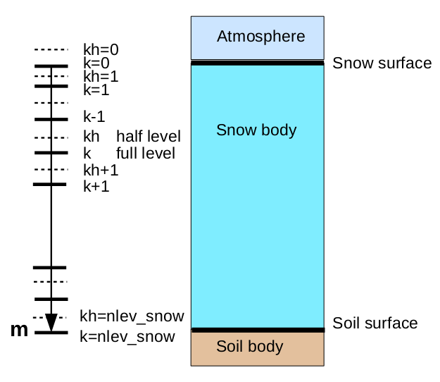
Fig 3. Scheme of the finite difference representation of the space coordinate in the snow layer.

6.1 Dynamics and balance of snow mass
The dynamics of the snow layer mass is determined by the variations of the two components of the snow layer: solid and liquid. The variations of the solid component takes place in the top snow level in presence of solid precipitation or sublimation/deposition of water vapour, while the other levels do not contribute to this process. The variations of the liquid component take place in presence of liquid precipitation falling on the top snow level and in case of snow melting in any layer; in this case liquid water flows in the lower layers or in the soil. The general balance of snow mass is determined by the sum of the water fluxes (in all the phases) at the top and bottom layers.
The water mass flux at the top layer is described in section 2 (see equations 41, 43, 44). At the bottom layer, the water mass flux is determined by the liquid water flux from the layer above. The process of water draining along the snow profile is described in the following way: all the liquid water that at the beginning of the time step is found at level k, at the end of the step is found at level k+1, this hypothesis is acceptable since empirical data show that even a very small liquid water draining speed is anyway higher than the values resulting from this hypothesis (the thickness of the snow layers is in the order of the centimeters and the time step is in the order of the minute). The liquid water flux at a half snow layer is thus:
, (72)
where Φ _{m} is the flux of liquid water at level kh (kg m⁻² s⁻¹), m_{k-1} is the specific (total) snow mass at level k-1 (kg m⁻²), f_{ice}^{snow}_{k-1} is the fraction of ice phase in the total snow mass at level k-1.
The water flux at the lowest snow half level is the water flux at the soil surface (see section 3).

6.2 Processes of heat conduction and water phase transition in the snow
As in the soil scheme, the main equation describing the thermodynamic state of the snow is the equation of entropy transport and conservation (see section 5). In the case of snow, for solving the entropy prognostic equation the splitting method is applied: first, the conductive entropy transport term is solved, then the entropy conservation in case of phase transition in the snow layer is solved.
Let us now consider the conductive transport. In mass coordinates, the equation has the following aspect:
, (73)
where S_{snow}^{spec} is the specific entropy of snow (J K⁻¹ kg⁻¹) and Φ_{S snow} is the snow entropy flux (J K⁻¹ m⁻² s⁻¹).
In analogy with soil entropy (see equations 60, 61) the total specific entropy of snow layer, including the solid and liquid phases of water, is defined as:
, (74)
where C_{snow}^{Σ} is the total specific heat capacity of snow including ice and liquid water (J kg⁻¹ K⁻¹), which can be rewritten, by making use of the concept of fraction of solid phase with respect to total mass, in the following way:
. (75)
The flux of conductive entropy transport is defined as:
, (76)
where λ_{snow} is the specific heat conductivity of snow (J s⁻¹ m⁻¹ K⁻¹) and ρ_{snow}^{Σ} is the total density of snow including ice and liquid water (kg m⁻³).
In this equation the density is not the density of the porous medium but it is a virtual density of the thermodynamically active medium, excluding the pore volume, defined as:
. (77)
At the same time, for the snow a density from the point of view of the porous medium is introduced, in order to define the characteristics of heat conductivity. This density is indicated with the symbol ρ_{snow}. This quantity is a diagnostic parameter defined at each snow layer, depending on the thickness of the snow layer, on the snow age at each layer and on the total period during which snow at every layer was subject to melting/freezing processes. The following method for determining diagnostic snow density is proposed in the present model:
, (78)
where τ_{snow} and τ_{snow}^{melt} are total snow age and total period during which snow was subject to melting (days), ρ_{firn}, ρ_{snow}^{fresh} and ρ_{snow}^{old} are density of firn, of fresh snow and of old snow (kg m⁻³), m is the snow mass in the current layer according to the vertical coordinate used (kg m⁻²). When density is determined, a limitation is applied, according to which the density variation cannot exceed 10% per day.
The heat conductivity of snow us defined following the study of J.Jin et al., 1999:
. (79)
When equation (73) is solved, the snow temperature including effect of heat conduction is determined, while the solid fraction does not change and is considered known.
We consider now the solution of the second part of the problem, i.e. the conservation of snow entropy in case of phase transition. The following quantity, equal to the entropy of a particular snow layer including liquid and solid phases, should be conserved:
, (80)
where S_{snow} is the entropy of soil water (J K⁻¹ m⁻²) and Δm is the specific mass of a snow layer (kg m⁻²).
In order to numerically solve equation (73) a discretisation of the vertical coordinate as shown in fig. 3 is used, together with a time-explicit method of approximation of fluxes and of their derivatives. The following finite-difference prognostic equation is thus obtained:
, (81)
where the indexes k and kh indicate respectively the values on the full and half vertical levels respectively, the upper indexes O and * indicate the values of temperature variables before and after the solution of the conductive heat transport equation respectively. The values of the physical parameters at half levels is computed as the arithmetic mean of the values at the surrounding full levels. In order to compute the overall virtual density (density used in thermodynamic contest) and heat capacity of snow, the value of solid fraction of snow layer at the beginning of the time step is used.
Solution of (81) allows to compute temperature T* after taking in account the conductive heat transfer but without considering the phase transition.
After having solved the first part of the split problem which provided the value of temperature T*, it is possible to define the value of soil water entropy, which is considered the definitive value at the end of the time step. For determining entropy, the finite different discretisation of (80) is used:
, (82)
where f_{ice k}^{snow 0} is the fraction of solid phase at level k before taking into account phase transitions.
Equation (82) includes two unknowns: temperature and fraction of solid phase. Unlike the case for soil moisture, it is assumed that in the snow layer the presence of water in liquid phase (f_{ice}^{snow}<1) is possible only at 0°C (T=T₀). This assumption simplifies the solution: either the initial temperature is T₀, then equation (82) has a single unknown, i.e. fraction of solid phase, or the initial temperature is below zero, then the only unknown is temperature which has to be below or equal zero Celsius. The temperature and fraction of solid phase determined in this way are considered definitive at the end of the time step.
As remarked in section 5, the solution of the thermodynamic state of snow layer is performed only when the amount of snow exceeds a given threshold in order to avoid numerical problems. If the snow specific mass is below the given threshold, its thermodynamic state is described by the solution of the entropy equation for the top soil level, whose entropy is augmented by the value of entropy for snow.
Solution of equation (82) allows to diagnose the length of the time interval during which snow is exposed to melting is diagnosed. The value of this interval is required for computing snow density.
In conclusion, the scheme of snow-layer processes defines the overall specific snow mass, the distribution of this mass in the vertical levels, and, at each level, the temperature, the fraction of solid phase, the snow age, the length of melting time-interval and the snow density.

7 Verification of «Pochva» scheme in NWP model Bolam in hindcast regime

The scheme “Pochva” described above has been coded in a way that is easily adaptable to any atmospheric model and is freely available. As input data, atmospheric variables at the lowest level are required, together with fluxes of precipitation, visible and infrared radiation, heat and humidity (or variables allowing to compute these fluxes). Besides these variables, quantities defining the physical characteristics of soil and vegetation are required. Soil characteristics are allowed to vary along the vertical direction as well. In “Pochva” the bottom boundary condition for temperature and soil moisture can be specified through a “climatological level”, with a horizontally-varying depth, depending on the local climatological and hydrological conditions, at which the values of temperature and moisture content are considered constant. The description of the methods used for defining the physical parameters of soil and vegetation and the method for defining the climatological level may be the subject of a future publication. Here we just note that the space variability of soil physical parameters has been defined on the basis of FAO dataset (FAO Unesco, 1997), the vegetation types and corresponding physical parameters have been defined using the GLC2000 dataset (Joint Research Centre, 2003), while, for defining the climatological levels, the analysis of 2 meter temperature for the period 1979-2014 from ECMWF ERA Interim dataset together with the FAO soil type dataset have been used.
In order to test the implementation, the “Pochva” scheme has been included in the NWP model “Bolam” (Buzzi et al., 1994, Buzzi et al., 1998) and in its global variant “Globo” (Malguzzi et al., 2011). Bolam is a hydrostatic NWP model on a limited area. A numerical experiment in hindcast regime has been set up with Bolam, the experiment consisted in a continuous integration of the model on a long period using objective analysis data as boundary conditions during all the period. As initial and boundary conditions, data from the ECMWF IFS model have been used from the ECMWF operational archive. The model domain included most of European territory. The time extent of the experiment covered the period June 2013-November 2015, where the first six months were used to let the soil layer reach the thermodynamical equilibrium with the climatological bottom boundary conditions, thus they have not been considered in the analysis of the results. In this way the effective period includes two full years, from beginning of December 2013 to the end of November 2015. The length of two years was chosen in order to exclude the presence of interannual oscillations and trends in the simulations.
In order to verify the results, data from standard meteorological observations from WMO GTS network have been used, retrieved from ECMWF archive. The main purpose of the numerical experiment was to evaluate the contribution of the “Pochva” scheme to the numerical modelling results, thus the variables used in the verification process were air temperature and dew-point temperature at two meter over surface.
The experiment showed that the main scores, such as mean error (bias) and root mean square error (RMSE), of near-surface temperature and humidity, stratified on monthly and seasonal intervals do not vary significantly among the two simulated years. This suggests that there is no significant trend due to error accumulation in the simulation. In the figures below, scores averaged on seasonal intervals based on the two simulated years are shown.
Figures 4 and 5 show seasonal averages of 2m temperature bias and RMSE over observation points. As it can be seen from fig. 4, the bias obtained is relatively low, mostly between -1⁰C and +1⁰C. A higher error is noticed in the cold seasons (winter, autumn), when Central Europe experiences a bias values between -1⁰C and -3⁰C (up to -5⁰C in mountainous areas) while at the east of Ural range the bias sign is opposite (+1⁰C +2⁰C). In the warm seasons, mainly in summer, a bias up to +5⁰C is noticed in the desert or semi-arid areas of Eastern Mediterranean.

a) | 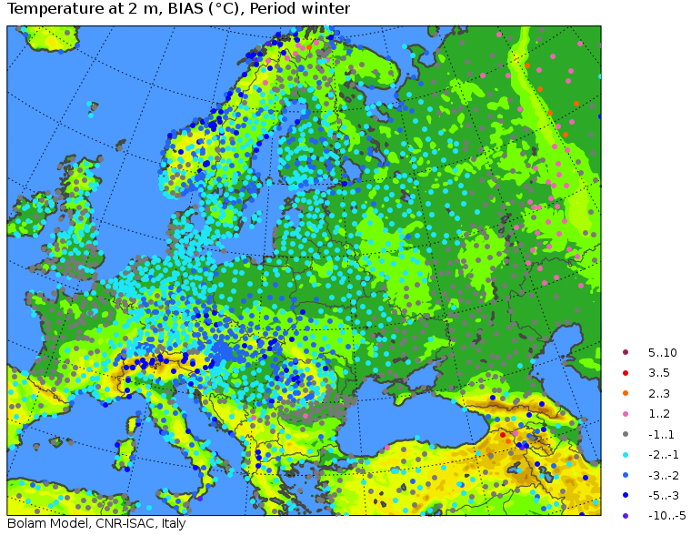 | c) | 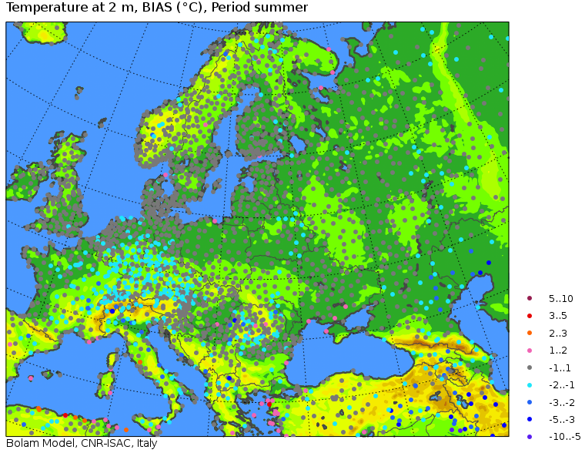
b) | 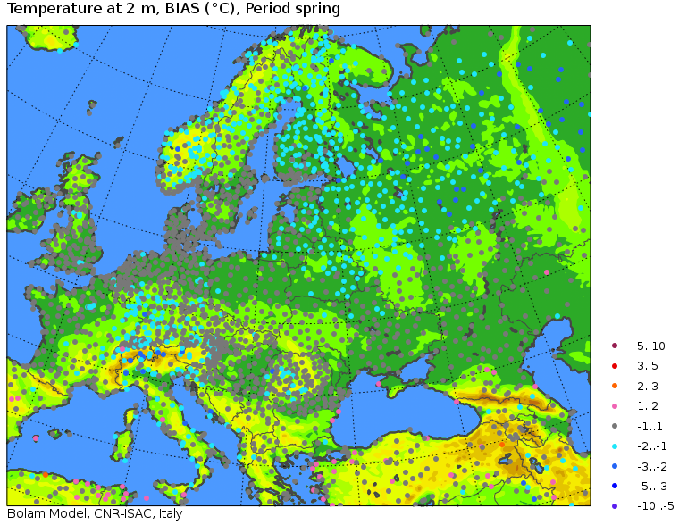 | d) | 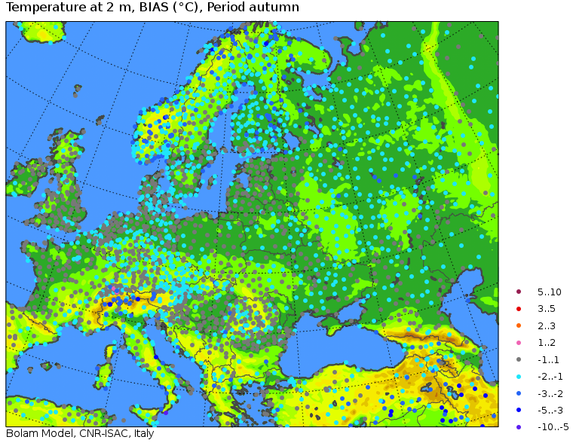
Fig.4. Seasonally averaged 2 meter temperature bias at observation points: a) winter, b) spring, c) summer, d) autumn.

a) | 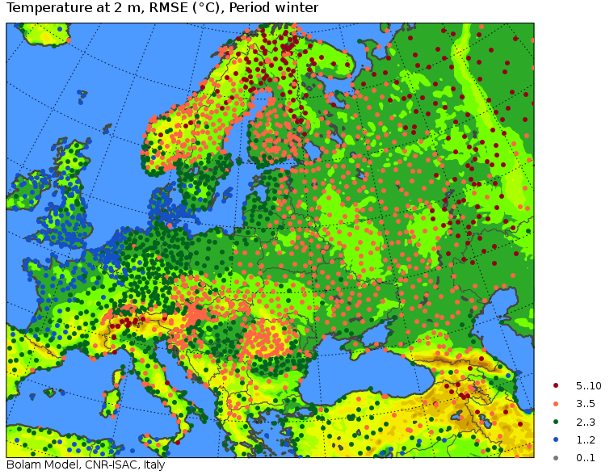 | c) | 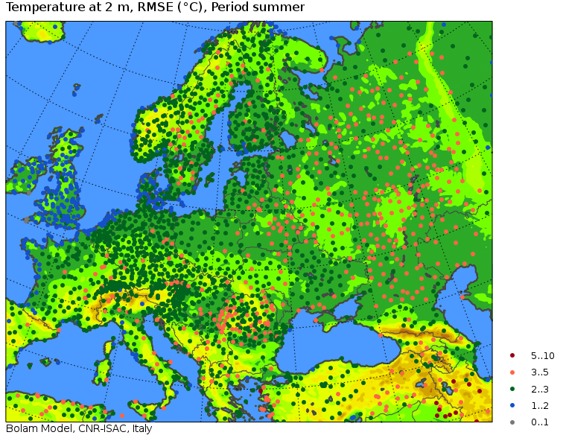
b) | 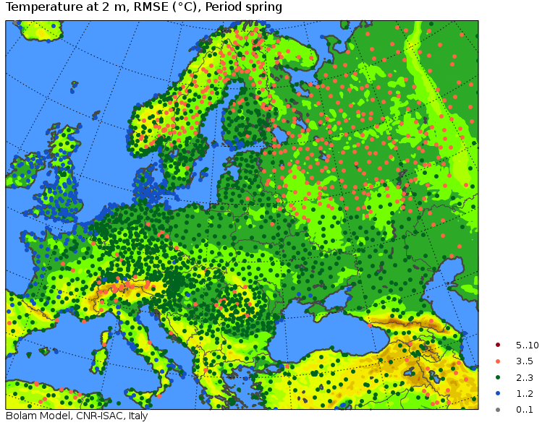 | d) | 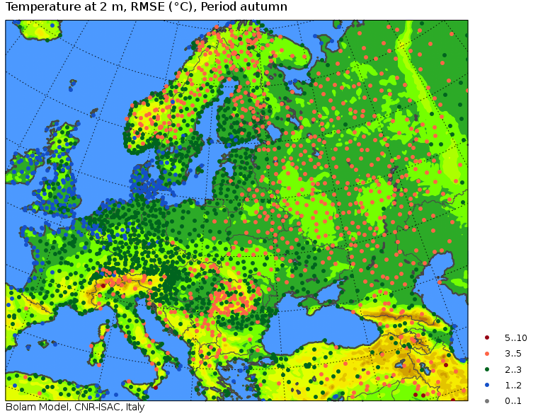
Fig. 5. Seasonally averaged 2 meter temperature RMSE at observation points: a) winter, b) spring, c) summer, d) autumn.

The RMSE shown in fig. 5 also shows that, on the background of an error with a magnitude of 2-3⁰C, the error is higher in the colder seasons especially in mountain and continental areas, up to 5⁰C. In general, coastal areas show lower RMSE, with values lower than 2⁰C, growing up to 3-5⁰C with growing distance from the sea.
It can be concluded that the overall near-surface atmospheric thermal regime is simulated with enough accuracy. The errors in the cold periods in continental and mountain areas can be explained by a poor simulation of the snow cover, which strongly influences the near-surface temperature, while high errors in desert areas during the warm periods can either be due to an error in the soil surface temperature or in the inaccurate representation of surface turbulent exchange in cases of dry thermal instability.
Fig. 6 shows the seasonal 2m dew-point temperature bias on observation points. In the cold seasons the systematic error is in the interval -1⁰C +2⁰C, while in the warm seasons the dew-point temperature (and thus air humidity) is overestimated in the continental areas, with a bias growing up to +3⁰C +5⁰C with increasing distance from the sea. Similar conclusions may be drawn from the analysis of seasonal RMSE, presented in fig. 7. In the coastal areas all year round and anywhere in the colder seasons, RMSE has low or moderate values, 1-3⁰C, while in the continental areas in the warm seasons it may grow up to 5⁰C and more. It can thus noticed that most of the RMSE is explained by the bias. The overestimation of air humidity in the continental areas during warm seasons is difficult to explain. The absence of a corresponding systematic error for temperature suggests that it is not due to an overestimation of evaporation, since, if that was the case, temperature would have been underestimated. It can be proposed that this is due to inaccuracy in the definition of water vapor fluxes or of the humidity profile in the surface layer in the warm season, i.e. in cases of neutral or unstable stratification.

a) | 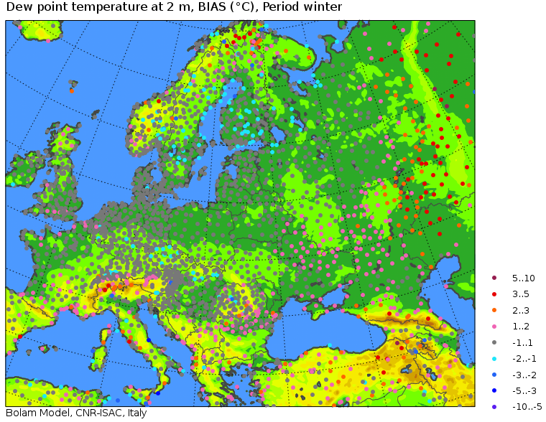 | c) | 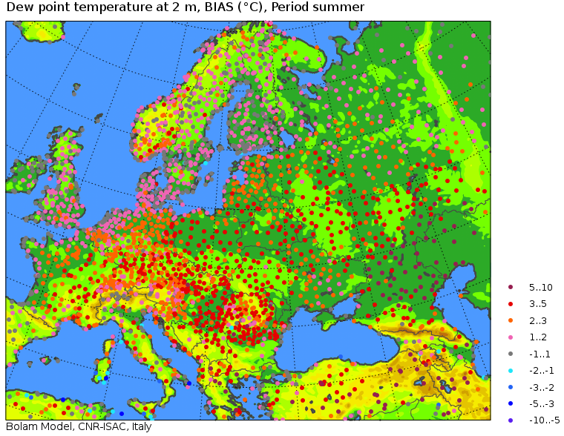
b) | 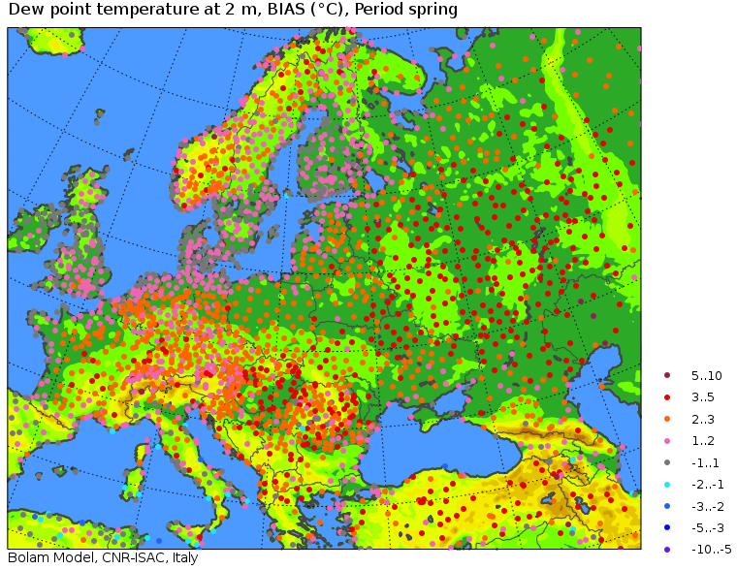 | d) | 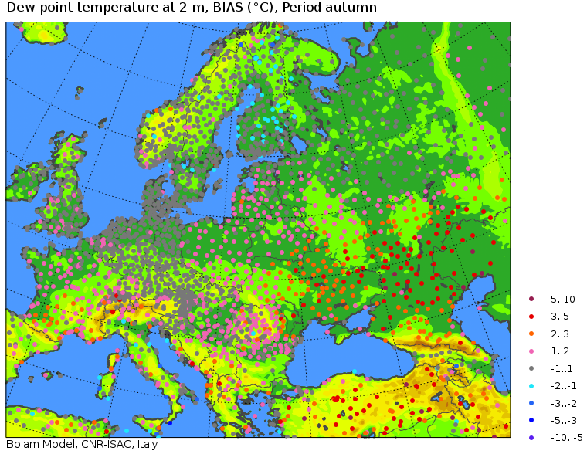
Fig. 6. Seasonally averaged 2 meter dew-point temperature bias at observation points: a) winter, b) spring, c) summer, d) autumn.

a) | 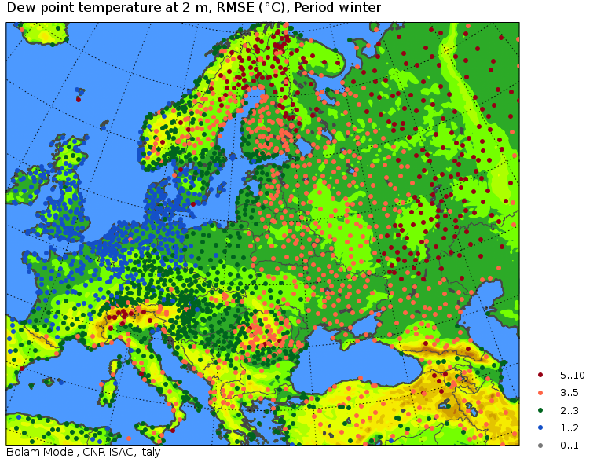 | c) | 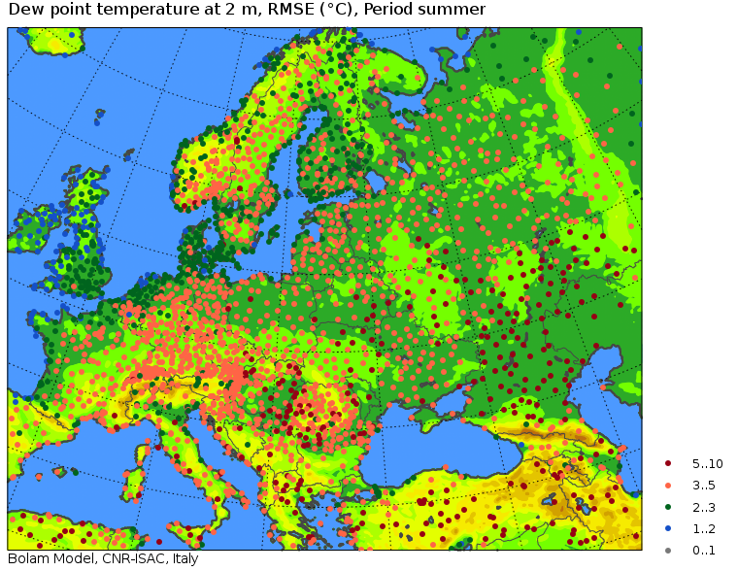
b) | 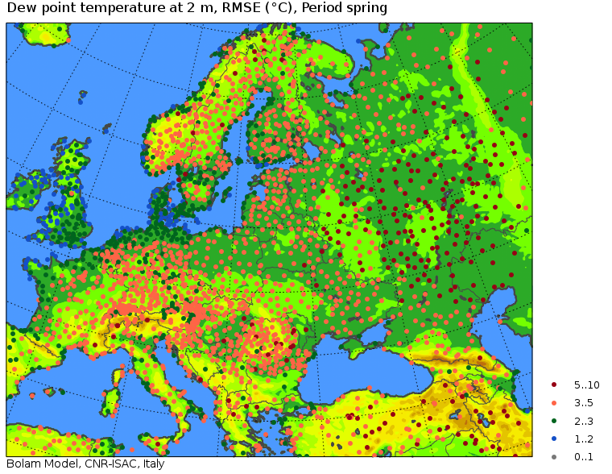 | d) | 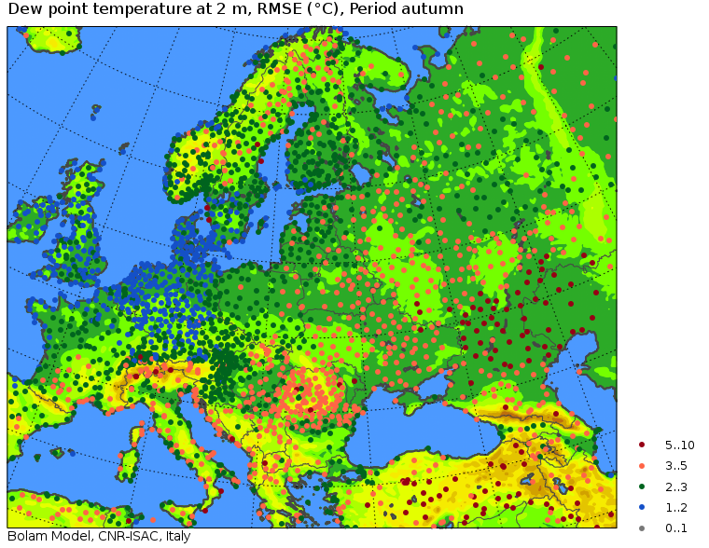
Fig. 7. Seasonally averaged 2 meter dew-point temperature RMSE at observation points: a) winter, b) spring, c) summer, d) autumn.

In order to examine more in detail the errors in near-surface air temperature and humidity from the point of view of the representation of daily cycle, the simulated and observed values for these variables at all the observation times, averaged on seasons and on specific geographical areas are here shown. Since the model domain covers areas with completely different meteorological and climatological characteristics, the geographical averaging has been carried out considering climatologically uniform areas. For this purpose, a dataset of the Köppen-Geiger climate classification has been used (Rubel and Kottek, 2010). Most of the observation points falls into six climatic areas according to the Köppen-Geiger classification, namely Bsk (cold steppe), Cfa (humid subtropical), Cfb (temperate oceanic), Csa (hot-summer Mediterranean), Dfb (warm-summer humid continental), Dfc (subarctic), moreover the points on mountain areas (defined as having height >1000m above mean sea level) were treated separately. Fig. 8 shows the distribution of observation points by climatic zone.

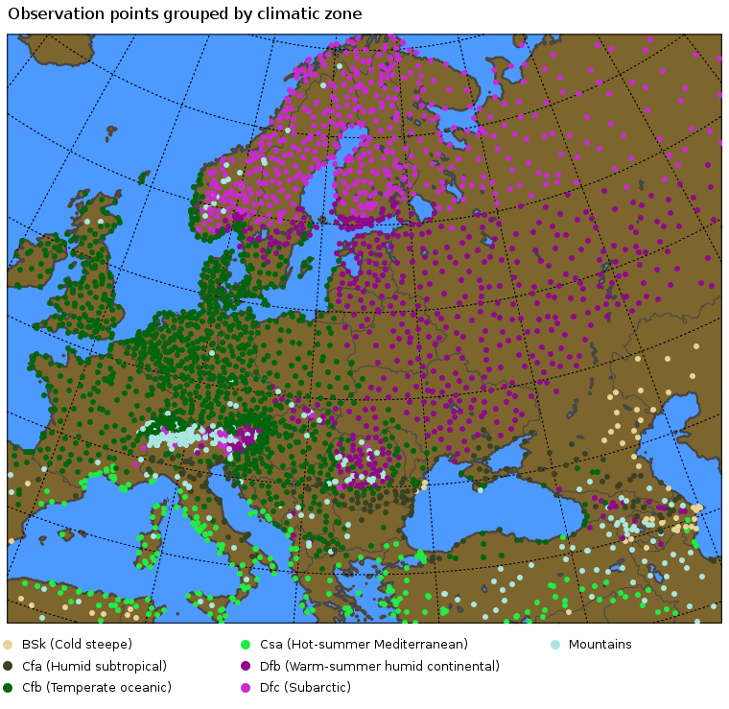
Fig. 8. Distribution of observation points by climatic zone according to Köppen-Geiger classification.

For all the observation points falling in each of the seven main climatic zones, two meter temperature and dew-point temperature bias and RMSE have been computed at all the times of the day at which observations are available, namely 0, 3, 6, 9, 12, 15, 18, and 21 UTC. Below, the error obtained in the representation of daily cycle in each climatic zone will be examined.
In winter period (fig. 9 and 10), the error does not depend on the time of the day in all the climatic zones except in the mountain areas, where the error is higher during the day. In most of the climatic zones, the error is mostly due to bias, which is quite low, -1.3⁰C -1⁰C, while RMSE is in the range 1-4⁰C, it is lower in the oceanic climate areas and it grows in areas with a continental climate. The zone with subarctic climate stands out from this picture, since it is characterised by low bias (-1.5⁰C) and high RMSE (4.5-5⁰C).

a) | 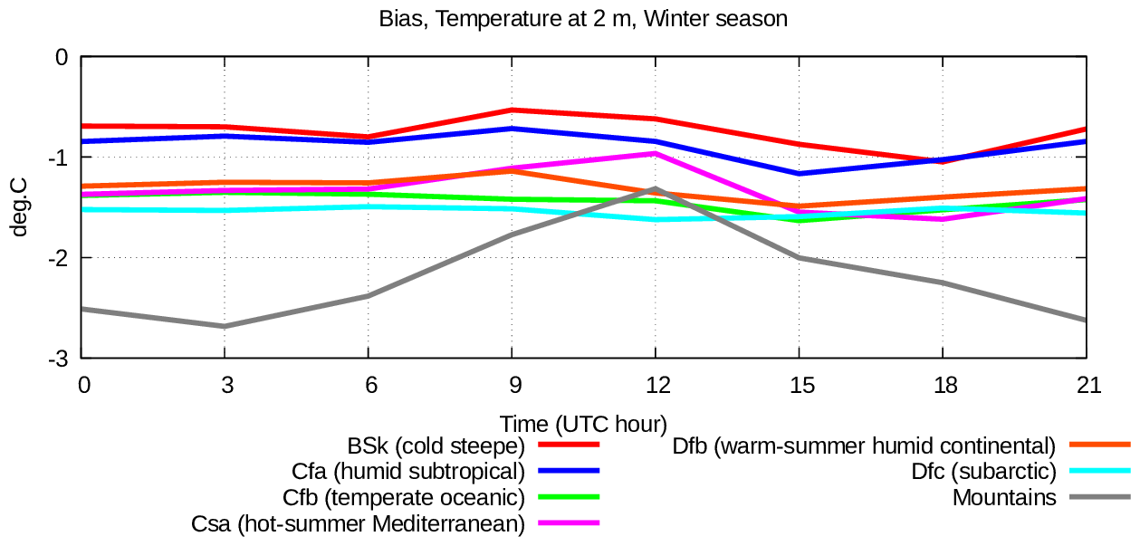
b) | 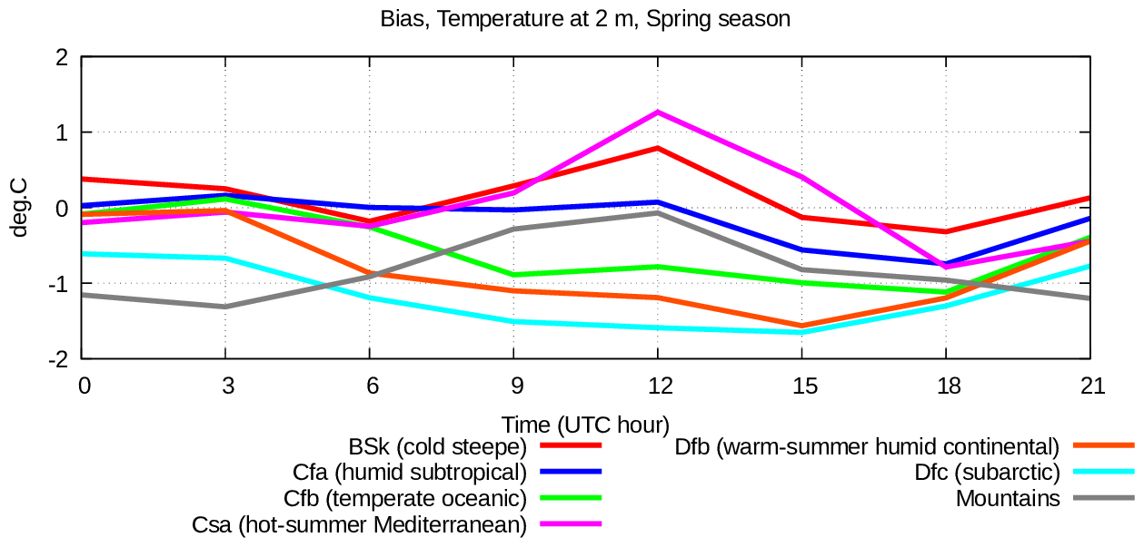
c) | 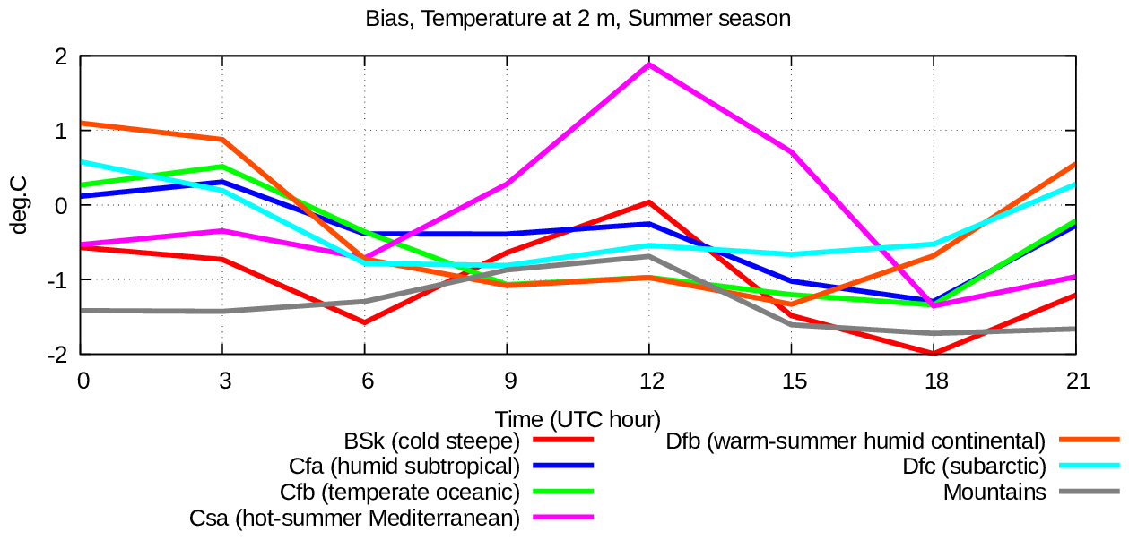
d) | 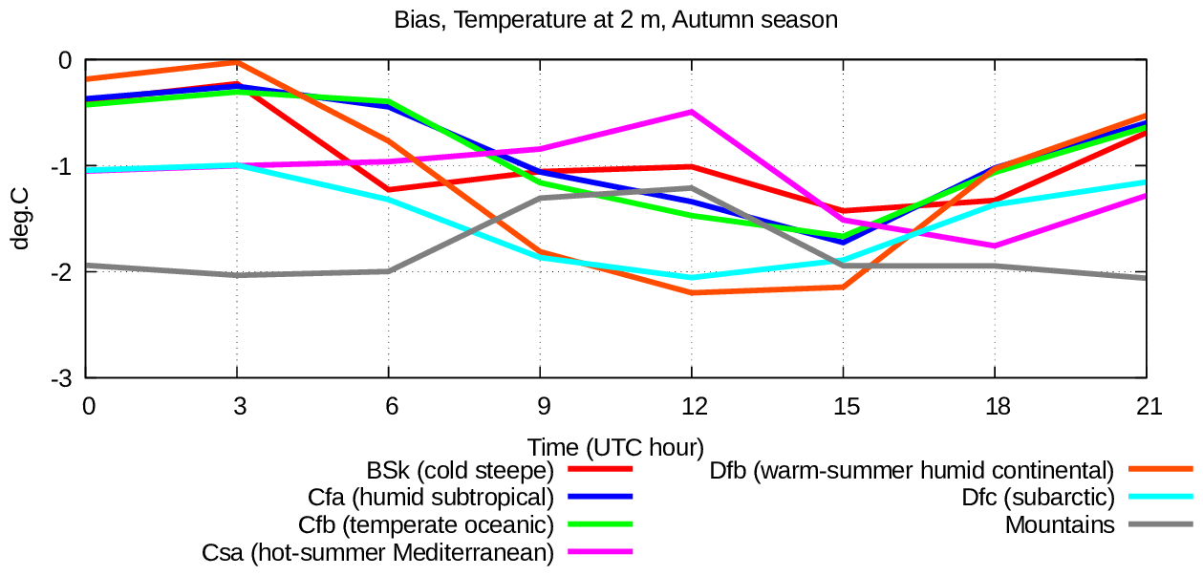
Fig. 9. Diurnal cycle of bias of simulated 2 meter air temperature for various seasons: a) winter, b) spring, c) summer, d) autumn, in various climatic zones: cold steppe (Bsk) red line, humid subtropical (Cfa) blue line, temperate oceanic Cfb green line, hot-summer Mediterranean (Csa) violet line, warm-summer humid continental (Dfb) orange line, subarctic (Dfa) azure line, mountains grey line.

a) | 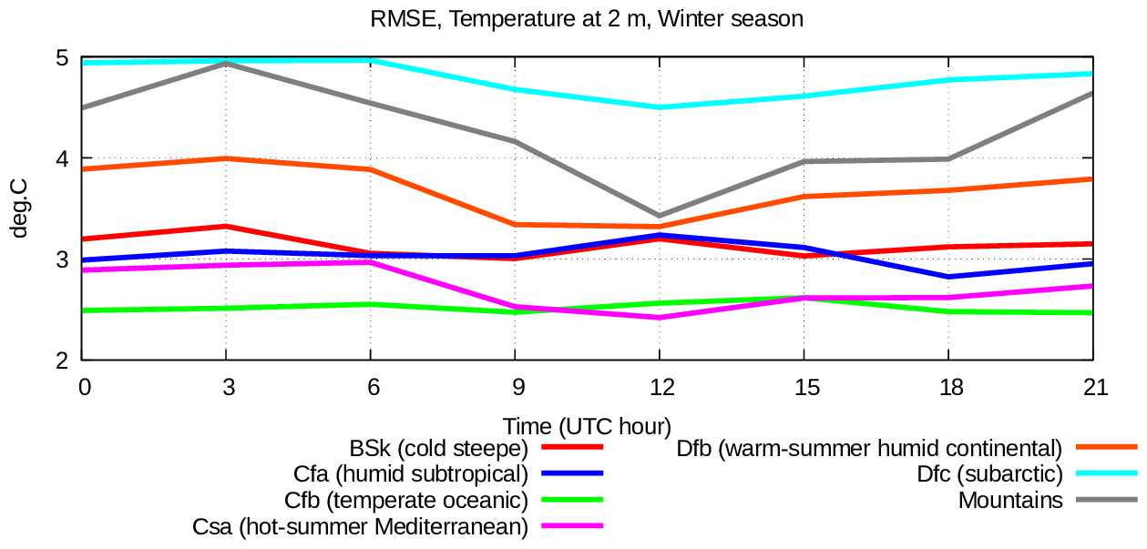
b) | 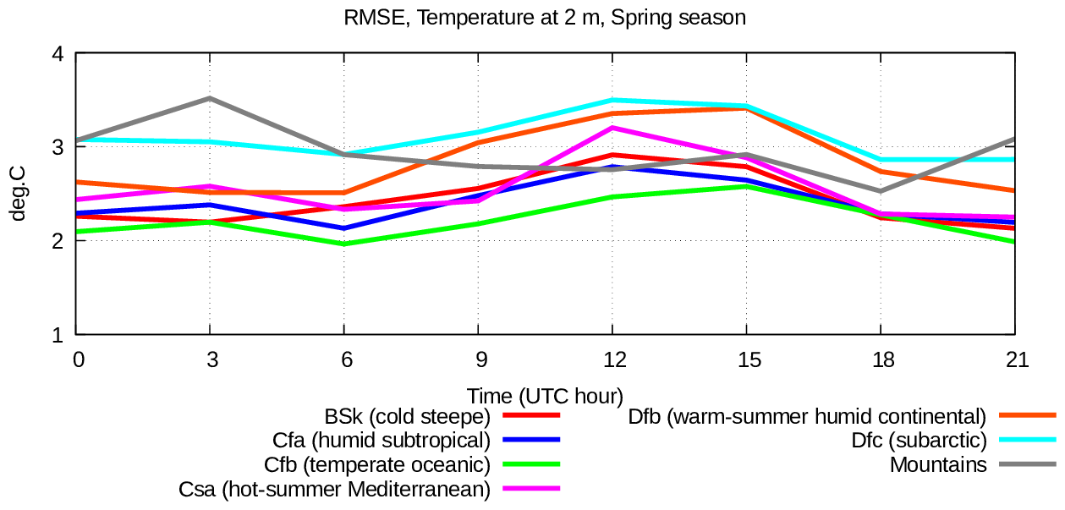
c) | 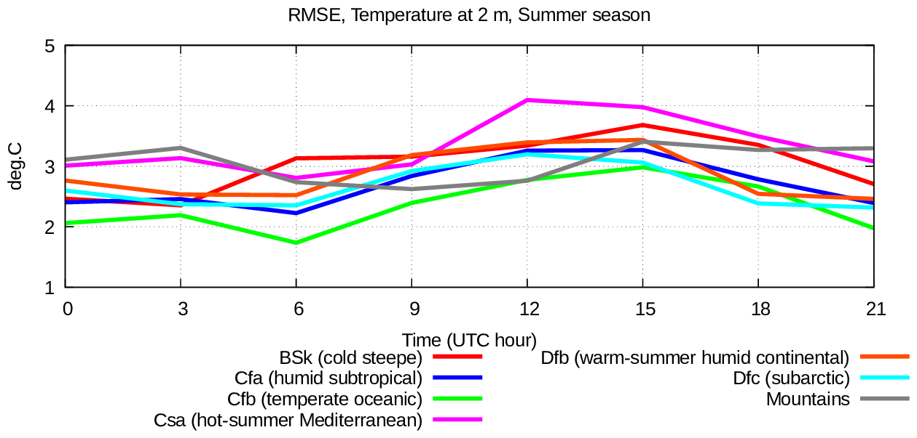
d) | 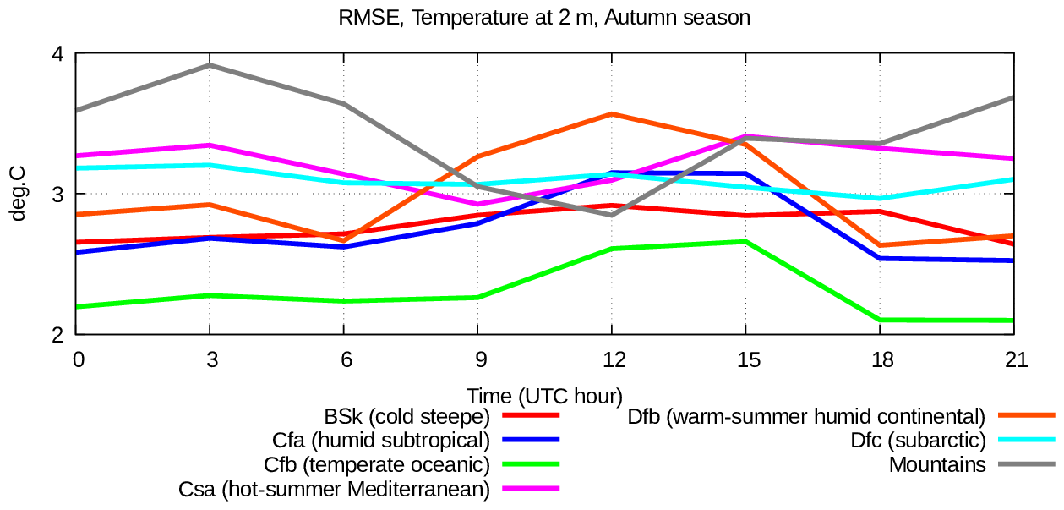
Fig. 10. Same as at fig. 9 but for RMSE of simulated 2 meter air temperature.

During the summer period (fig. 9 and 10), all the climatic zones are characterised by the fact that bias explains most of the RMSE (2-4⁰C); bias is in the range -2⁰C +2⁰C and it is positive during daytime and negative in the evening and morning hours. This is particularly evident in the zones with dry climate, such as “hot summer Mediterranean” and “cold steppe”. This could be possibly due to some problems in the representation of the surface sensible heat flux in the presence of an unstable surface layer, or in the surface latent heat flux, or due to the insufficient heat capacity of the higher soil layer which, in turn, could be due to too low values of soil moisture. In areas with mountain and subarctic climate, the score is significantly better in summer than in winter. This is possibly due to deficiencies in the representation of snow cover or of the radiative characteristics of the snow cover itself.
In the spring and autumn periods, (fig. 9 and 10, panels b and d) the scores for 2m temperature have intermediate values between those for summer and winter. The overall errors are not high, the bias ranges between -1.5⁰C and +1.5⁰C, while RMSE is around 2-4⁰C. In spring the error characteristics are closer to the summer ones, while in autumn they are closer to the winter ones. It is probably the case that the processes of formation and melting of the snow layer in the areas with a stable winter snow cover (warm-summer humid continental, subarctic and mountains) are simulated more or less correctly, since no increase of the error is observed in these transitional seasons.
Concerning the scores for humidity in terms of dew-point temperature, at two meters, figures 11 and 12 show the daily cycle of the bias and RMSE for this variable.
In the winter period (fig. 11 and 12, panel a) all the climatic zones are characterised by a low systematic error (0⁰C +2⁰C) and a significant RMSE (2-5⁰C) with a very weak daily cycle. In the same way as for temperature, the scores strongly depend on the climatic zone: better scores (RMSE up to 3⁰C) are found in the area with oceanic climate (temperate oceanic, hot-summer Mediterranean, humid subtropical), while worst scores (RMSE higher than 4⁰C) are found in zones with cold continental climate (warm-summer humid continental, subarctic, mountains). This can be due to deficiencies in the definition of latent heat flux or air humidity profile over snow layer, i.e. in cases of stable surface layer.
In the summer period, on the other hand, most of the RMSE (2.5-8.5⁰C) is explained by systematic error (0⁰C +6⁰C) which is always positive, i.e. the air humidity is systematically overestimated. In general, the minimum of daily error occurs ad daytime, while it is maximum in the evening and night. This may be due to a suboptimal tuning of the turbulent exchange parameterisation in neutral and stable boundary layer conditions. In the areas characterised by oceanic climate or in cold climate areas (temperate oceanic, subarctic) the errors are lower, while in dry areas (cold steppe) they are higher. At the time of day when errors are higher, the overestimation of air humidity is accompanied by underestimation of air temperature. This may be an evidence of deficiencies in the computation of latent heat flux (evaporation).
In winter and autumn seasons (fig. 11 and 12, panels b, d) the dew point temperature scores, similarly to the case of temperatures, have intermediate values between those found in winter and summer seasons. In general, the air humidity is almost always overestimated, in the warm season more than in the cold one.

a) | 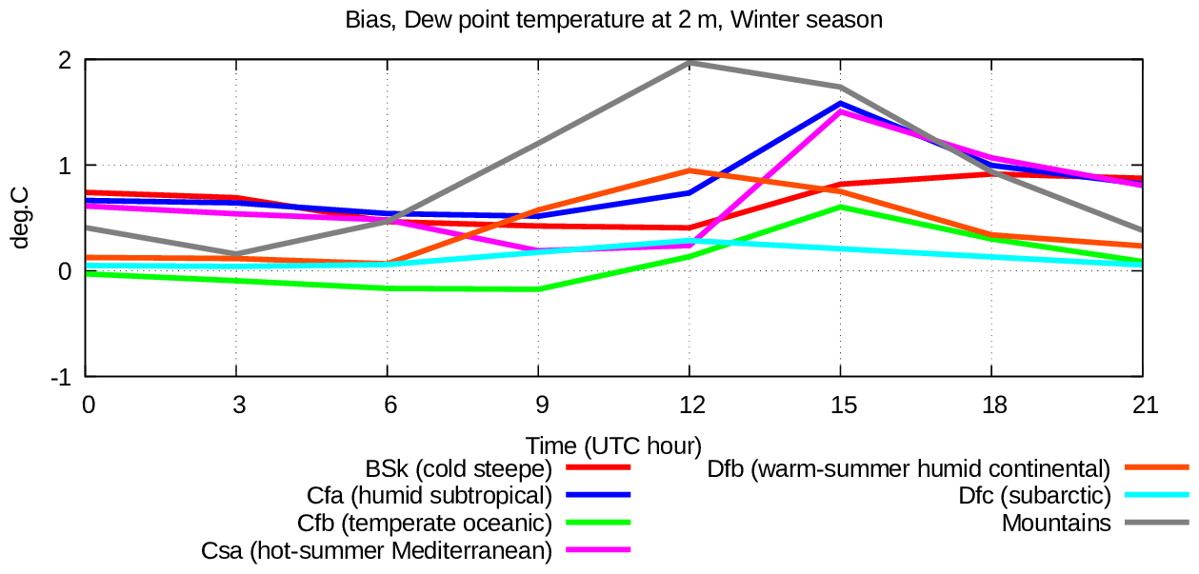
b) | 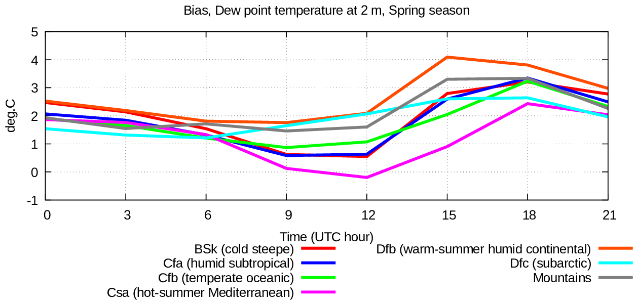
c) | 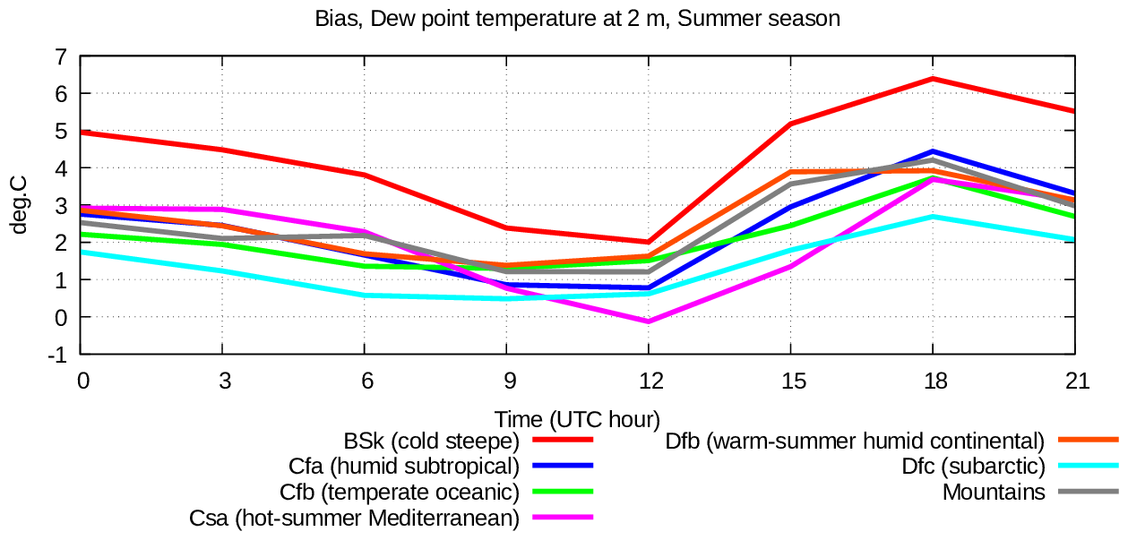
d) | 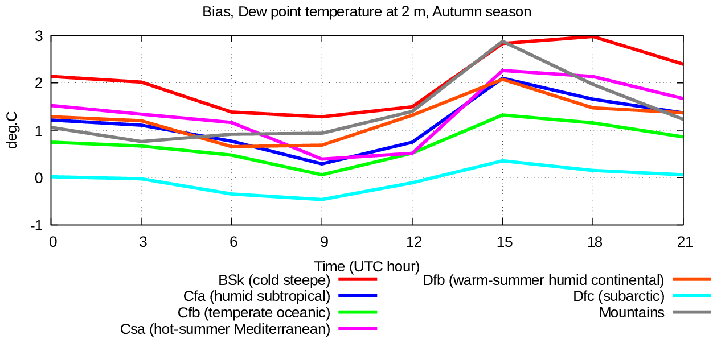
Fig. 11. Diurnal cycle of bias of simulated 2 meter dew-point temperature for various seasons: a) winter, b) spring, c) summer, d) autumn, in various climatic zones: cold steppe (Bsk) red line, humid subtropical (Cfa) blue line, temperate oceanic Cfb green line, hot-summer Mediterranean (Csa) violet line, warm-summer humid continental (Dfb) orange line, subarctic (Dfa) azure line, mountains grey line.

a) | 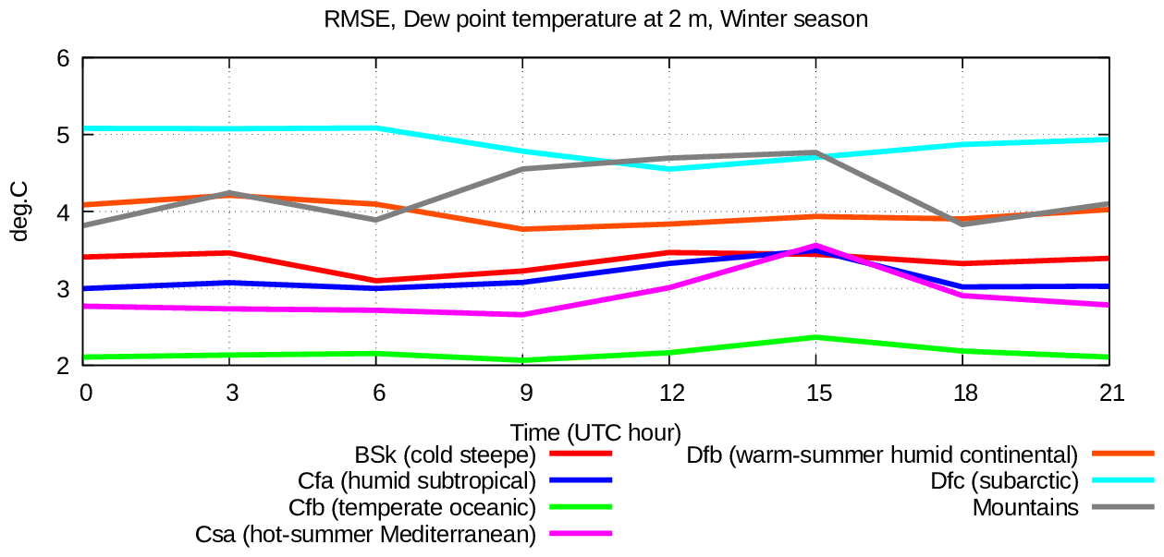
b) | 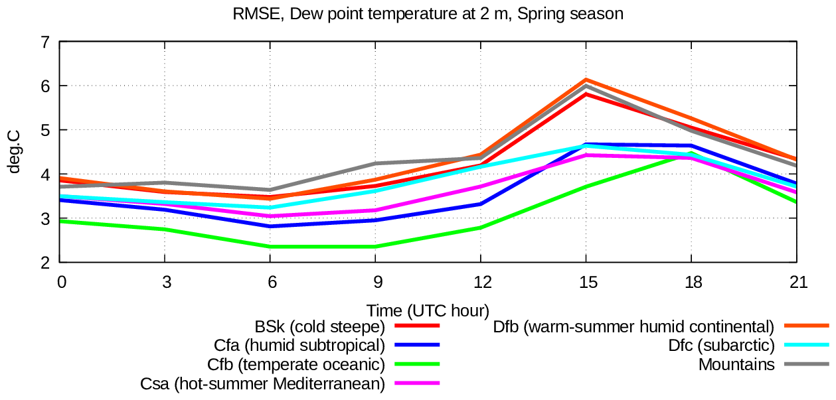
c) | 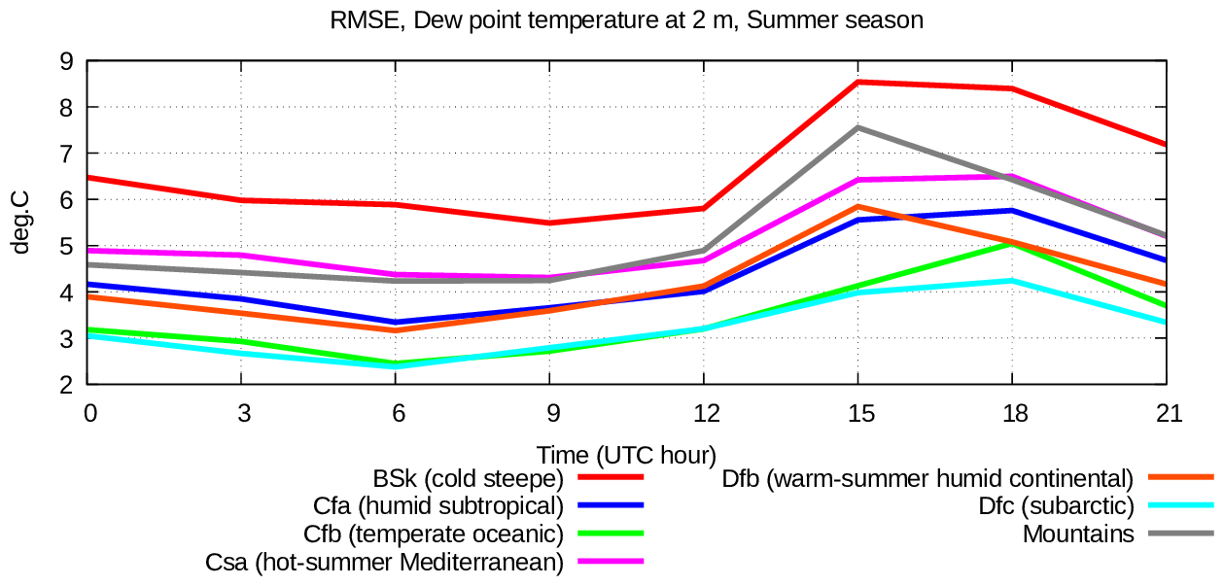
d) | 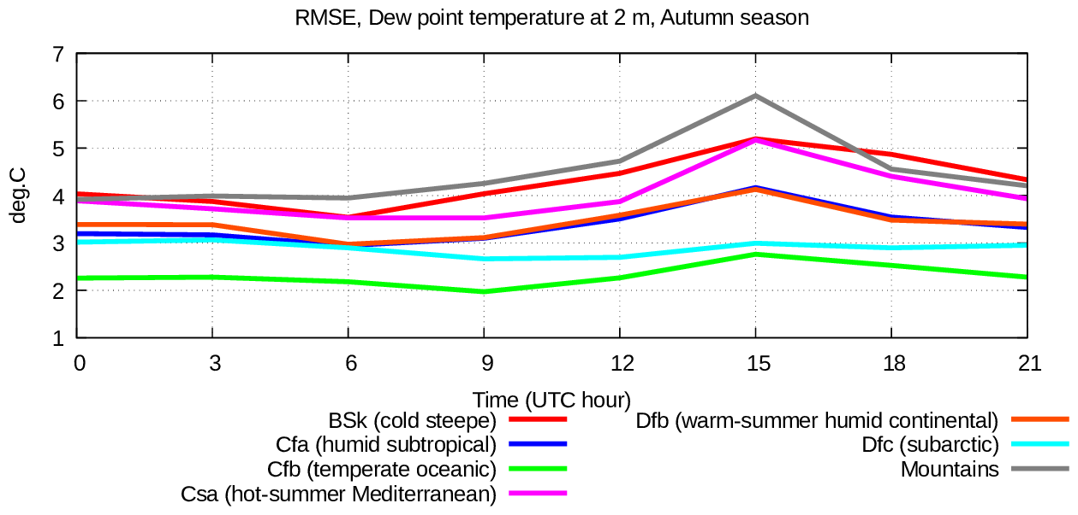
Fig. 12. Same as at fig. 11 but for RMSE of simulated 2 meter dew-point temperature.

The scores presented here show no evidence of systematic deficiencies in the near-surface temperature, with the exception of periods characterised by a stable snow cover, when temperature is systematically underestimated, or of summer periods in dry climatic zones when daytime temperature is overestimated. At the same time, near-surface air humidity is systematically overestimated, especially in summer time, and, in particular, in dry climatic areas at evening and night time.
As a general conclusion the results shown by the numerical experiments with the scheme “Pochva” are definitely convincing.

10 Summary
The model of hydro-thermal processes in vegetated soil and snow cover presented in this work is characterized by a special attention to soil-water phase transition, and by novel approaches to define some soil and snow physical parameters. The proposed model has been validated by a solid verification presented in this work consisting in a two year hindcast experiment. The presented model may be useful for modeling research over polar or cold climate zones, in permafrost evolution studies, in studies and forecast of snow cover, in studies of surface layer in stable conditions over cold surfaces. The models is realized using an effective and stable numerical algorithm with a clear, intuitive interface that allows a simple coupling to an atmospheric model or to observational of air surface layer and energy and water fluxes.
This land model has been included in the CNR-ISAC NWP models: Globo (hydrostatic approximation, global domain), Bolam, described above, and Moloch (non-hydrostatic, high space resolution at limited area). The indicated NWP models with “Pochva” are used from 2018 up to present day for the routine operational weather prediction in CNR-ISAC for Civil Protection Department of Italy. Forecast products are available at https://www.isac.cnr.it/dinamica/projects/forecasts/ and results of forecast verification are available at https://www.isac.cnr.it/dinamica/projects/forecast_verif.

Code availability
The model code in stand alone version for column test simulations is available at https://gitlab.com/oxana-meteo/pochva-stand-alone with DOI 10.5281/zenodo.12721822.
The package of CNR-ISAC models, including “Pochva” scheme is open source code freely available at https://gitlab.com/isac-meteo/globo-bolam-moloch.

Acknowledgments
The author wishes to express the acknowledgment to the principal CNR-ISAC NWP models developers Piero Malguzzi and Andrea Buzzi (CNR-ISAC, Italy), with whom the author has co-operated for more than 20 years in model development, the author has gained invaluable experience when working with these colleagues.
The author would like to thank Dmitry Pressman (Hydrometeorological Research Center of the Russian Federation) for her knowledge of physical process modelling in soil and for her background in NWP model development.
The author would like to thank the Italian National Computing Centre “CINECA” for providing the computational resources with which the simulations, presented in this paper, were performed.

Reference

Arduini G., Balsamo G., Dutra E., Day J.J., Sandu I., Boussetta S., Haiden T., 2019: Impact of a multi‐layer snow scheme on near‐surface weather forecasts. Journal of Advances in Modeling Earth Systems, vol. 11, pp. 4687– 4710. https://doi.org/10.1029/2020MS002144.
Best et al.:, 2011: The Joint UK Land Environment Simulator (JULES), model description – Part 1: Energy and water fluxes - Geosci. Model Dev., 4, 677–699 .
Buzzi, A., M. Fantini, P. Malguzzi and F. Nerozzi, 1994: Validation of a limited area model in cases of Mediterranean cyclogenesis: surface fields and precipitation scores. Meteorol. Atmos. Phys., 53, 137-153.
Buzzi, A., N. Tartaglione and P. Malguzzi, 1998: Numerical simulations of the 1994 Piedmont flood: Role of orography and moist processes. Mon. Wea. Rev., 126, 2369-2383.
Clapp, R. B. and Hornberger, G. M., 1978: Empirical equations for some soil hydraulic properties - Water Resour. Res., 14, 601–604.
Dai Y., Zeng X., Dickinson R.E., Baker I., Bonan G.B., Bosilovich M.G., Denning A.S., Dirmeyer P.A. Houser P.R., Niu G., Oleson, K.W. Schlosser C.A., Yang Z.-L., 2003: The common land model - Bulletin of the American Meteorological Society, vol. 84, issue 8, pp. 1013-1024.
Deardorff, J. W., 1978: Efficient prediction of ground surface temperature and moisture with inclusion of a layer of vegetation - J. Geophys. Res., 83, 1889–1903.
Ek, M. B., Mitchell, K. E., Lin, Y., Rogers, E., Grunmann, P., Koren, V., Gayno, G., and J. D. Tarpley, J. D., 2003: Implementation of Noah land surface model advances in the National Centers for Environmental Prediction operational mesoscale Eta model - J. Geophys. Res., 108, 163–166.
Endrizzi, S., Gruber, S., Dall’Amico, M, and Rigon, R., 2014: GEOtop 2.0: simulating the combined energy and water balance at and below the land surface accounting for soil freezing, snow cover and terrain effects — Geosci. Model Dev., 7, 2831–2857.
FAO — Unesco: «Soil map of the world» - Tecnical Paper 20, Food and Agriculture Organization of the United Nations, United Nations Educational, Scientific and Cultural Organization, International Soil Reference and Information Centre, 1997.
Jin J., Gao X., Sorooshian S., Yang Z.-L., Bales R., Dickinson R.E., Sun Sh.-F., Wu G.-X.: One-dimensional snow water and energy balance model for vegetated surfaces, 1999 - Hydrol. Process. 13, 2467-2482.
Joint Research Centre, 2003: «Global Land Cover 2000 database. European Commission, Joint Research Centre» - http://forobs.jrc.ec.europa.eu/products/glc2000/glc2000.php
Malguzzi, P., A. Buzzi and O. Drofa, 2011: The meteorological global model GLOBO at the ISAC-CNR of Italy: assessment of 1.5 years of experimental use for medium range weather forecast. Wea. Forecasting, 26, 1045-1055.
Noilhan, J. and Planton, S., 1989: A simple parameterization of land surface processes for meteorological models - Mon. Weather Rev., 117, 536–549.
Oleson, K. W., Lawrence, D. M., Bonan, G. B., Flanner, M. G., Kluzek, E., Lawrence, P. J., Levis, S., Swenson, S. C., Thornton, P. E., Dai, A., Decker, M., Dickinson, R., Feddema, J., Heald, C. L., Hoffman, F., Lamarque, J. F., Mahowald, N., Niu, G. Y., Qian, T., Randerson, J., Running, S., Sakaguchi, K., Slater, A., Stockli, R., Wang, A., Yang, Z. L., Zeng, X., and Zeng, X., 2010: Technical Description of version 4.0 of the Community Land Model CLM), 257 pp., 2010.
Peters-Lidard, C. D., Blackburn, E., Liang, X. and Wood, E. F., 1998: The effect of soil conductivity parametrization on surface energy fluxes and temperature. -J. Atmos. Sci., 55, 1209-1224.
Pielke R., 2013 - Mesoscale Meteorological Modeling — book, Academic Press.
Rubel, F., and M. Kottek, 2010: Observed and projected climate shifts 1901–2100 depicted by
world maps of the Koppen-Geiger climate classification - Meteorologische Zeitschrift, 19, 135-141; koeppen-geiger.vu-wien.ac.at/shifts.htm
Santanello J.A. Jr, Dirmeyer P. A., Ferguson C.R., Findell K.L., Tawfik A.B., Berg A., Ek M., Gentine P., Guillod B.P., Van Heerwaarden Ch., Roundy J., Wulfmeyer V., 2018: Land–atmosphere interactions: The LoCo perspective - Bulletin of the American Meteorological Society, vol. 99, issue 6, pp. 1253-1272.
Verseghy, D. L., 1991: CLASS – a Canadian land surface scheme for GSMS - I. Soil model, Int. J. Climatol., 11, 347–370.
Verseghy, D. L., Lazare, M., and McFarlane, N., 1993: CLASS – A Canadian land surface scheme for GSMS, II. vegetation model and coupled runs - Int. J. Climatol., 13, 111–133.
Viterbo, P. and Beljaars, A. C. M., 1995: An Improved Land-Surface Parameterization Scheme in the Ecmwf Model and Its Validation - J. Climate, 8, 2716–2748.

