Appendix A

A test of “Pochva” scheme in column version has been performed using observational data of Coordinated Energy and Water Cycle Observation Project (CEOP) Baltic Sea Experiment (BALTEX). The observed data have been used as forcing parameters for “Pochva” simulation, for determining the physical parameters of soil profile and for defining the initial condition. The observed data have also been used for the verification of simulation results. The observations have been performed in Falkenberg, a site at the Meteorological Observatory of the German Meteorological Service. This site is located in grassland fields, in a heterogeneous rural landscape typical for central Europe. The observational data are freely available upon individual request.
To apply the soil scheme offline, the values of soil physical parameters and soil temperature and water content profiles need to be defined at the beginning of the simulation and top and bottom conditions for the prognostic variables need to be defined for each time step during the simulation. A time step of 1 minute was used in the simulation. Values of soil physical parameters in Pochva simulation have been defined following the values measured at the observation point and presented in table A1 taken from dataset documentation (Beyrich, BALTEX: Lindenberg Soil Temperature and Soil Moisture Data Set., 2011). The initial condition for prognostic variables, soil temperature and soil water content, can be defined using the measurements at the soil levels. The bottom boundary conditions for prognostic variables can be defined using observation data at the lowest measurement level interpolated in time. The top boundary condition for prognostic variables, surface temperature, surface air humidity, surface soil water content, can be defined by heat and water mass fluxes at the surface: radiation flux (global net and visible incident), sensible and latent heat flux, precipitation flux and water vapour flux. The indicated surface fluxes have to be defined using the measurement data at the surface and in the air surface layer.
The observation dataset contains measurement for the following variables: soil temperature at 0.05, 0.10, 0.15, 0.20, 0.30, 0.45, 0.50, 0.60, 0.90, 1.00, 1.20, 1.50 m depth, specific volumetric soil water content at 0.08, 0.15, 0.30, 0.45, 0.60, 0.90 m depth, pressure and temperature at the surface, air temperature and air humidity at 2.4 m above the surface, wind at 10 m above the surface, pressure, air temperature, air humidity and wind at 40 and 80 m above the surface, downward and upward short-wave and long-wave solar radiation at the surface, precipitation at the surface, sensible and latent heat flux 2.4 m above the surface. These data are presented in (Beyrich, BALTEX: Lindenberg Soil Temperature and Soil Moisture Data Set., 2011), (Beyrich, BALTEX: Lindenberg Meteorological Tower Data Set., 2011).
To avoid vertical interpolation of simulated data when comparing with observations, the Pochva simulation uses the same soil levels where soil temperature and water content measurements are available, namely: 0.02, 0.05, 0.08, 0.10, 0.15, 0.20, 0.30, 0.45, 0.50, 0.60, 0.90, 1.00, 1.20, 1.50 m depth. The bottom condition for soil temperature is defined at 1.5m depth using the bottom temperature measurement level, whereas, the bottom condition for soil water content is defined at the 0.9 m depth using the bottom measurement level for this parameter. Since in these simulations the lower boundaries for the prognostic variables are not deep, a few days of simulation may be sufficient to reach the numerical thermodynamic equilibrium regime.
The indicated measurement list contains all the parameters required for defining the top soil boundary condition. These parameters are also named “atmosferic forcing parameters”. They are the following: sensible and latent heat flux at 2.4 m above the surface, downward and upward short-wave and long-wave radiation at the surface, precipitation at the surface (water varour flux at the surface cat be estimated using observed latent heat flux).

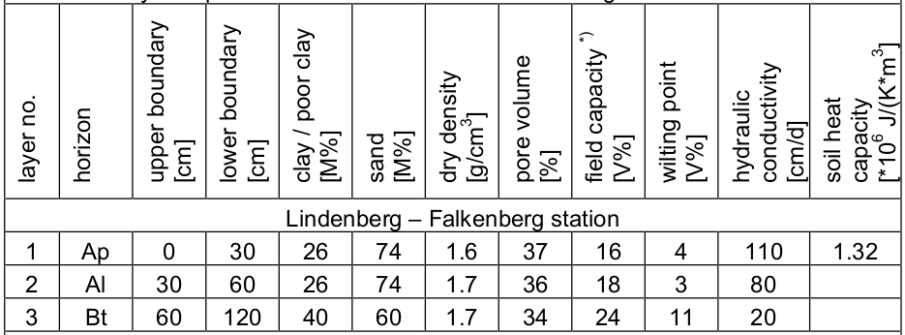
Table A1. Physical parameters of the soil at the Lindenberg - Falkenberg observation station.

The observation datasets contains the data for the period 01/01/2002-31/12/2009. All observed data have time resolution equal to 30 minutes. The author has developed a program that reads data from the database for various parameters, identifies the times at which data for all the atmospheric forcing parameters are available, and produces a list of the times found. Another program finds periods without gaps in the obtained list. A third program searches in the database the measurements for all required forcing parameters within the periods of continuous measurements, interpolates these data in time with trhe step specified for the model simulation (1 minute) and prepares all necessary data for the Pochva simulation.
Unfortunately, this search revealed very frequent gaps in the measurements of surface heat fluxes. A search for periods with gaps of no more than two hours for all the required forcing parameters resulted in 90 periods, the longest of which had a length of 4 days. However, if heat fluxes are excluded from the search of continuous measurement periods, then a vary long period of 913 days is found. Therefore, the author decided to perform two types of simulations: one exclusively with the “Pochva” model using all atmospheric forcing parameters from measurements, the other with the “Pochva” model coupled with a model of air surface layer processes, which simulates surface heat fluxes using measurements of wind, pressure, air temperature, air humidity at a height of 40 m and at the surface.
The author selected two periods for the first type of Pochva simulations, one in summer and one in winter. The initial condition have been defined using the observation data on the dau and time of the simulation start. The simulation results and their comparison with the observation data are presented below.
The summer verification period is 01/07/2003 23:00 – 04/07/2003 04:30 (53.5 hours). Input data on energy fluxes at the surface and water mass fluxes are shown in figure A1.
Figure A1. Observation data (BALTEX) in Falkenberg 2-3 July 2003, parameters at the surface: (a) solar radiation and heat fluxes (W m⁻²); (b) precipitation and evaporation rate (kg m⁻² hour⁻¹).

These July days are characterised by intensive net radiation flux accompanied by moderate sensible and latent heat fluxes, latent heat flux is significant only after light rain in the first day.
The simulated soil temperature and moisture data at same depth levels are shown in figures A2 and A3 together with observed data.

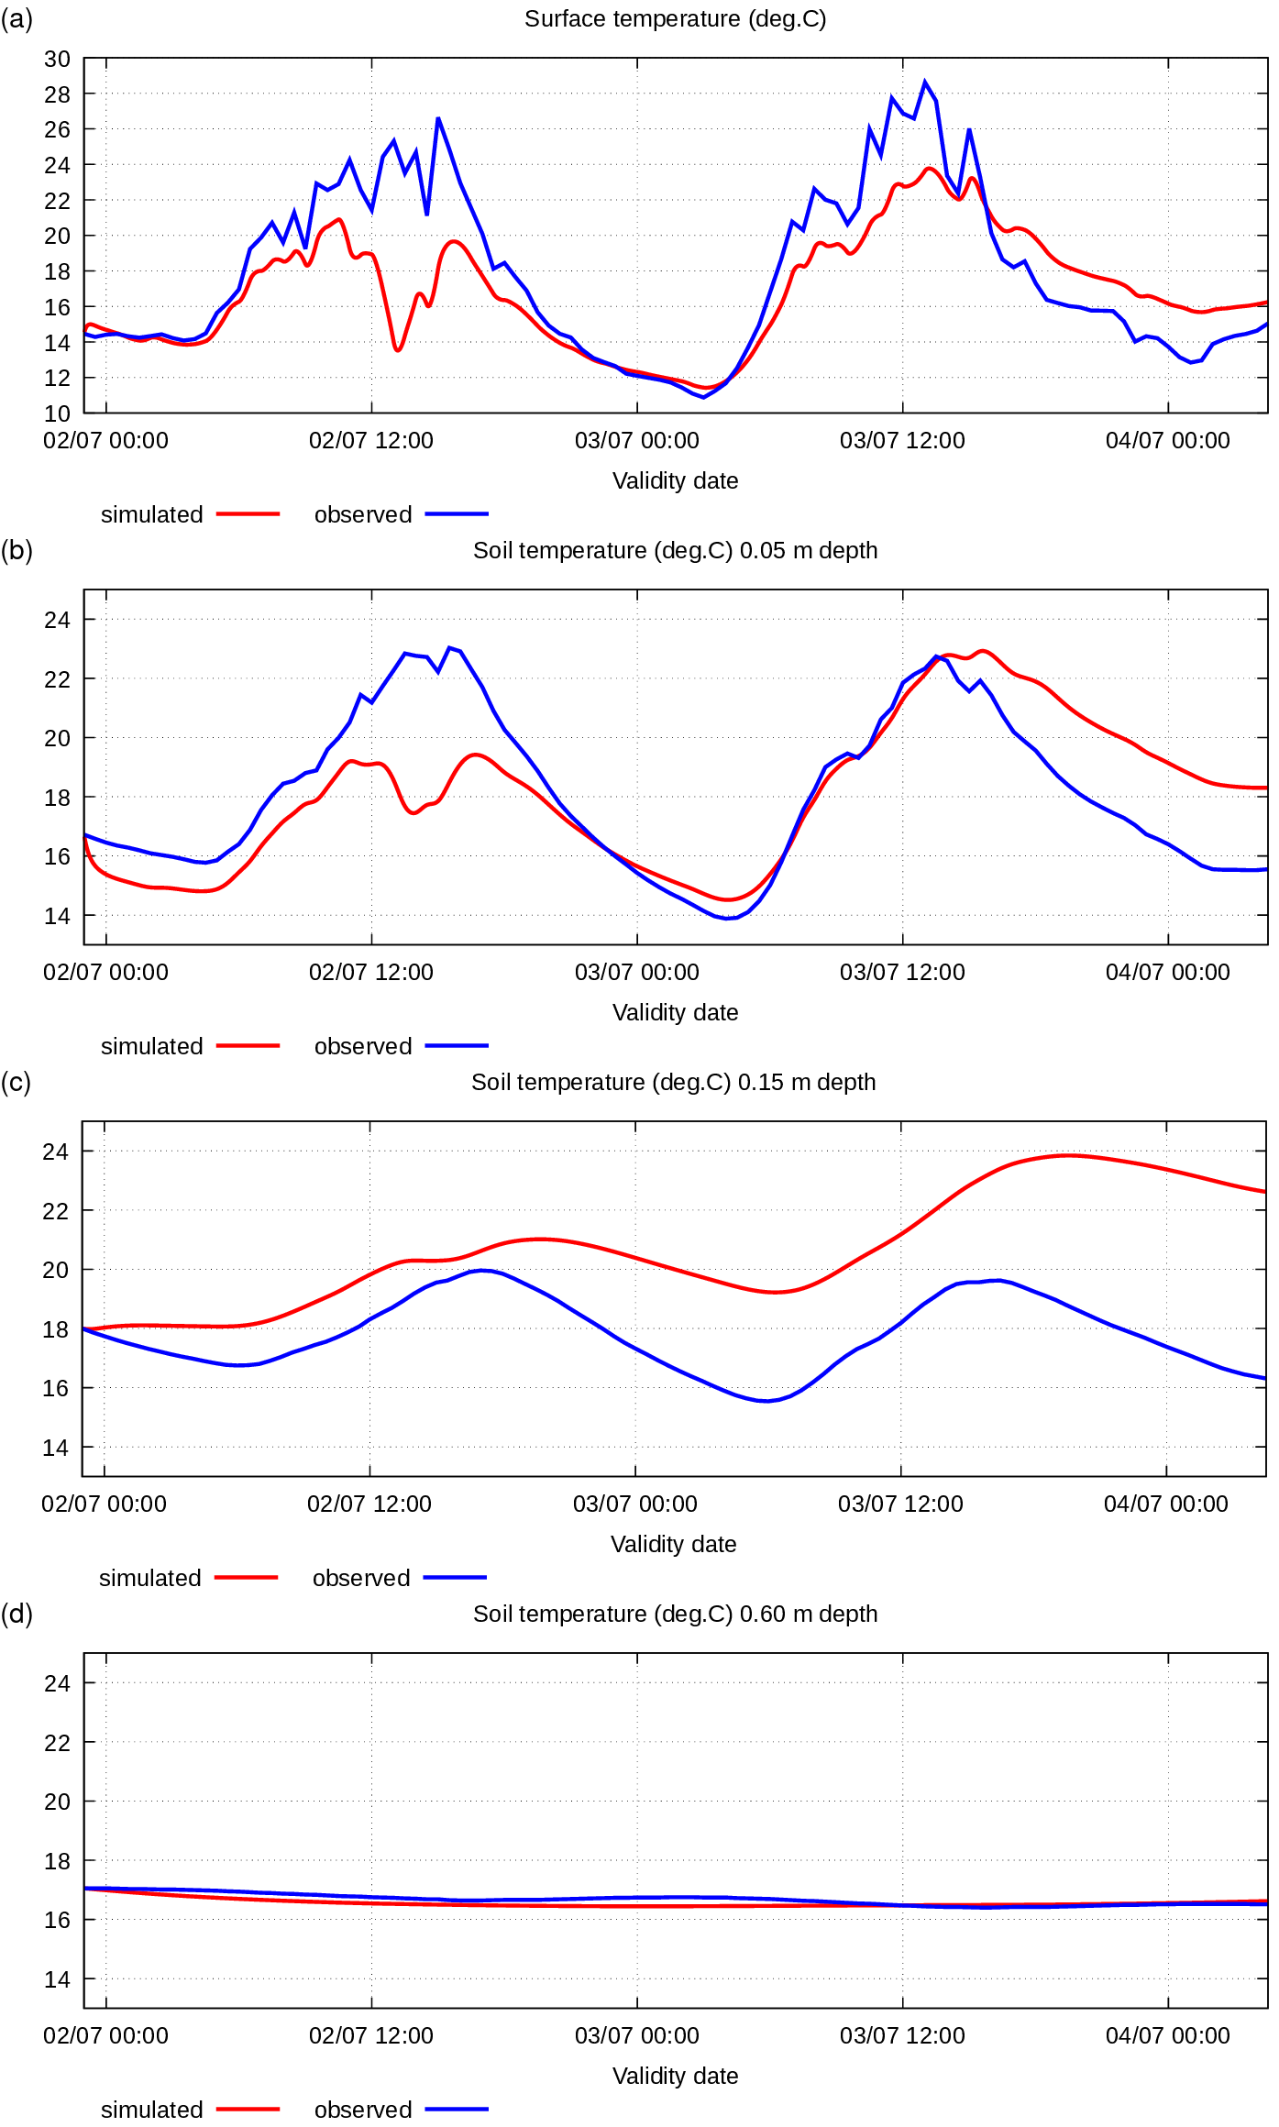

Figure A2. Simulated and observed 2-3 July 2003 soil temperature (°C) at the surface and at various depths: (a) surface; (b) -0.05 m; (c) -0.15 m; (d) -0.60 m.

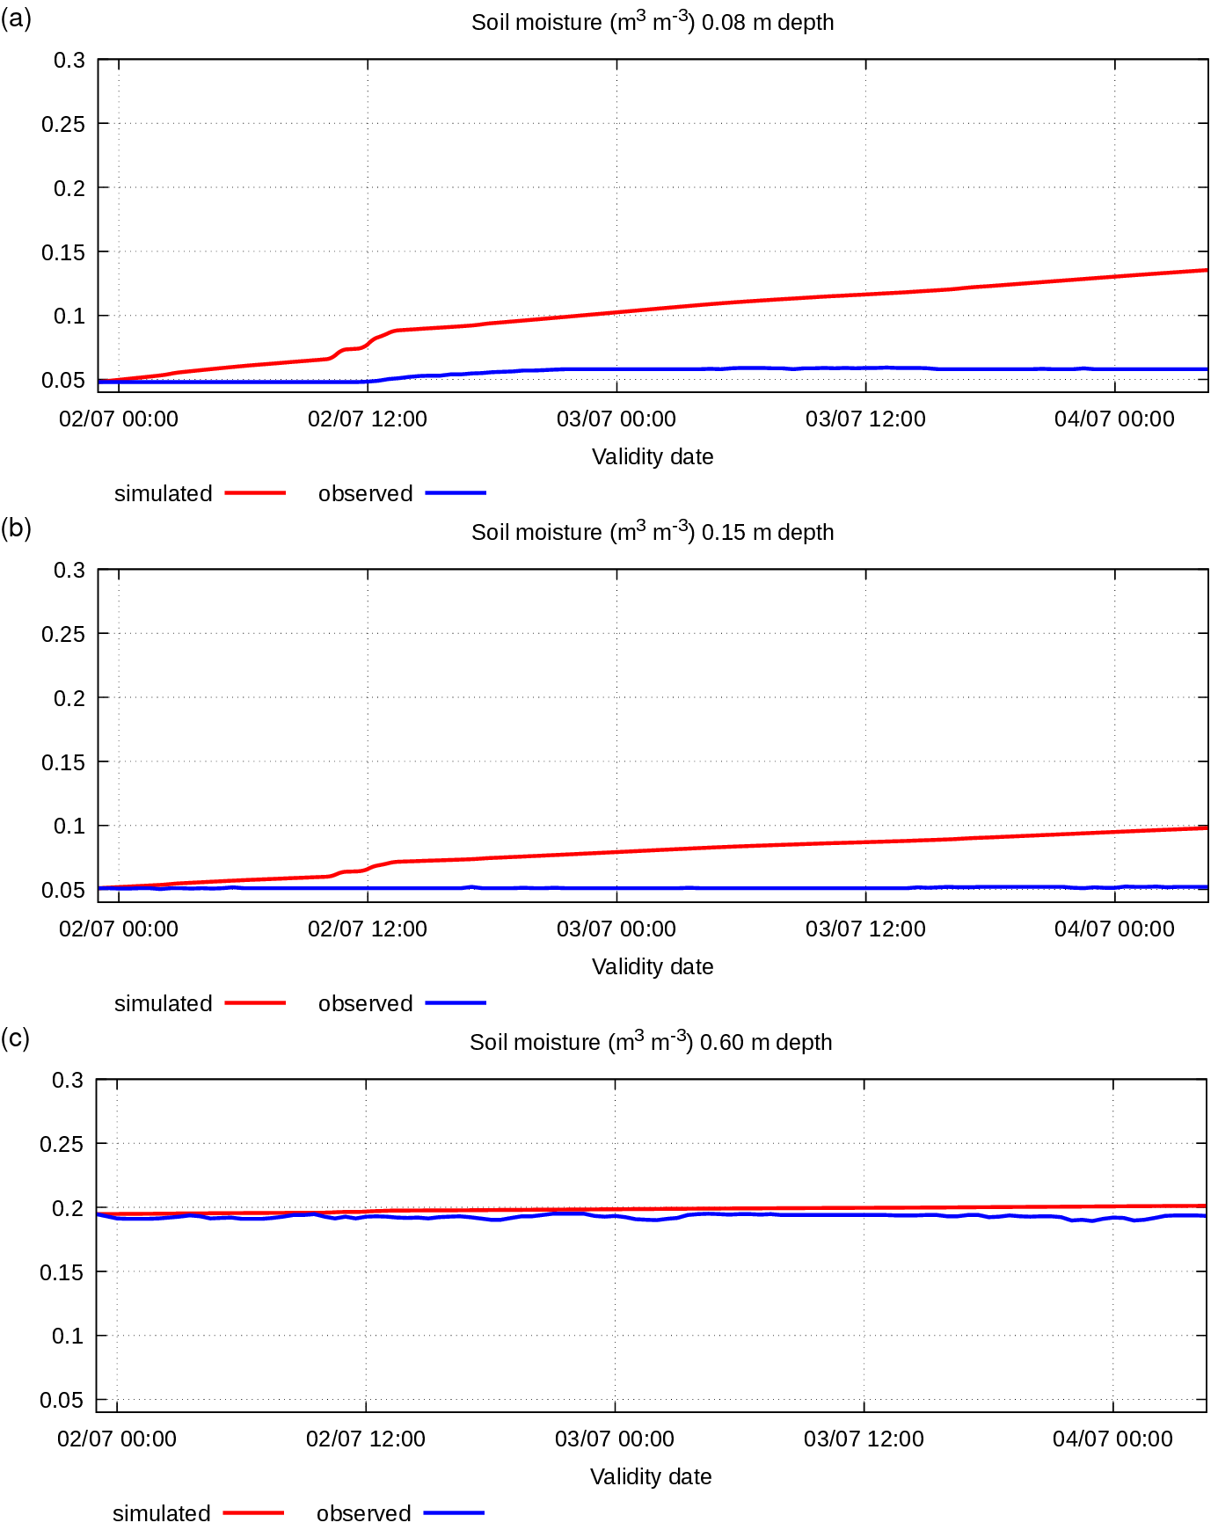
Figure A3. Simulated and observed 2-3 July 2003 soil specific volumetric water content (m3 m-3) at various depths: (a) -0.08 m; (b) -0.15 m; (c) -0.60 m.

Figures A2 and A3 show that the simulated soil parameters at the different levels are out of numerical equilibrium. Despite this fact, the simulated parameter values are close to observed values. The soil temperature simulated at various levels shows a correct daily cycle especially at the surface and at the top soil levels, which are important for an atmospheric model parameterisation. Moreover, the observation data show some odd characteristics: A light rain was observed on 02/07 at 12:30 (fig. A1(b)) accompanied by a sharp decrease in solar incoming radiation flux and an increase in outgoing latent heat flux, thus determining a strongly negative energy budget at the surface. This phenomenon is simulated by Pochva, simulated surface and soil top temperature evidently drop at this time, while, on the other hand, the observed surface and soil top temperature do not reflect this phenomenon. Furthermore, the observed soil moisture at different levels remains unchanged despite the presence of significant vertical gradient of soil moisture, rain and evaporation in the observation data.
The winter verification period is 08/01/2005 17:30 – 12/01/2005 12:30 (91 hours). Input data on energy fluxes at the surface and water mass fluxes are presented in figure A4.

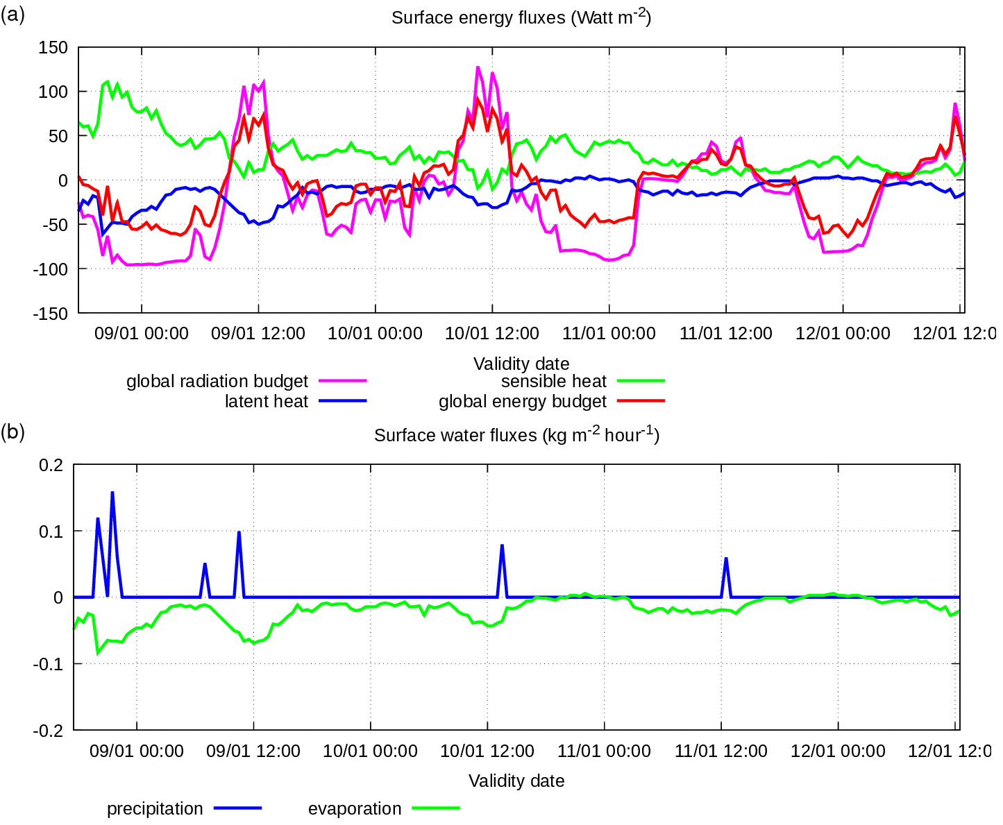
Figure A4. Observation data (BALTEX) in Falkenberg 8-12 January 2005, parameters at the surface: (a) solar radiation and heat fluxes (W m⁻²); (b) precipitation and evaporation rate (kg m⁻² hour⁻¹).

This January period is characterised by intensive radiation net flux in the first and second days with significant daytime heating and nighttime cooling, accompanied by weak sensible and latent heat fluxes with the exception of the first night, when significant sensible heat flux is observed; latent heat flux is significant only after light rain in the first day. Some episodes of very light precipitation occur. The evaporation flux has small values.

The simulated soil and moisture data at same depth levels are presented in figures A5 and A6 together with observed data.

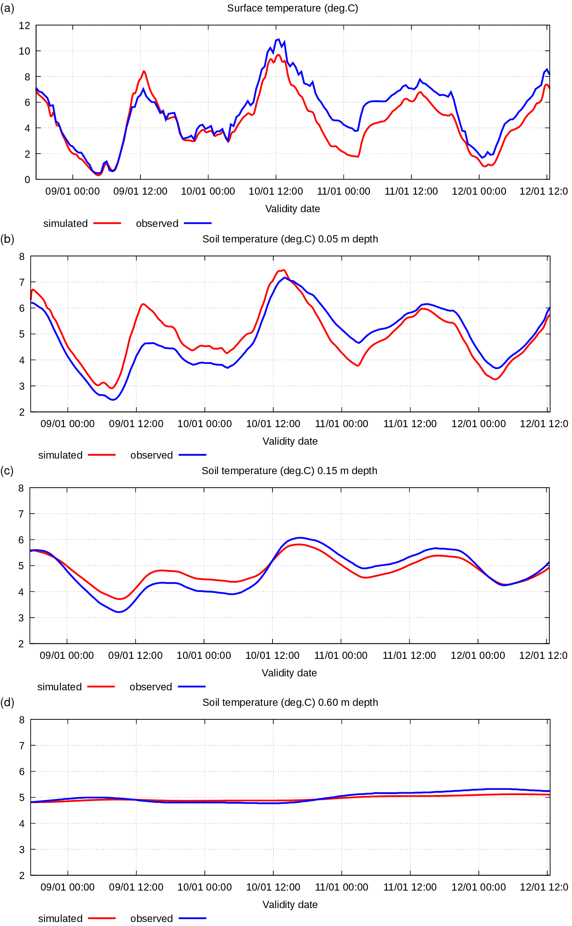

Figure A5. Simulated and observed 8-12 January 2005 soil temperature (°C) at the surface and various depths: (a) surface; (b) -0.05 m; (c) -0.15 m; (d) -0.60 m.

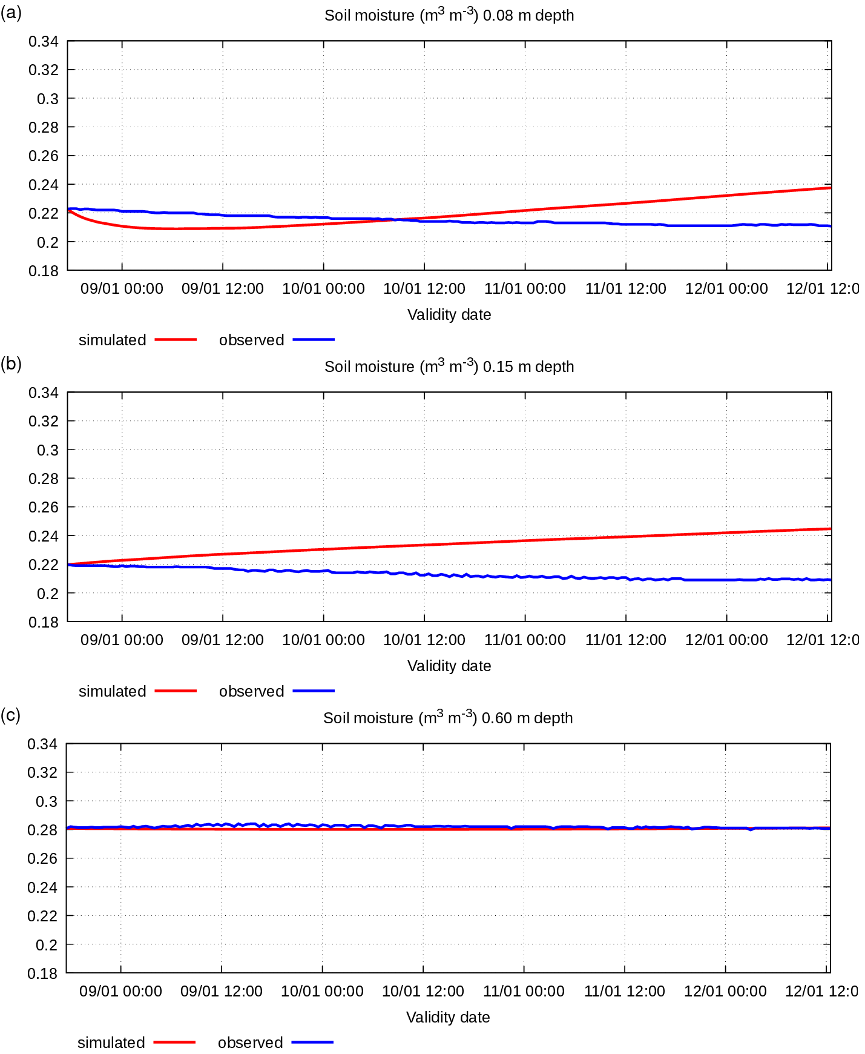
Figure A6. Simulated and observed 8-12 January 2005 soil specific volumetric water content (m3 m-3) at various depths: (a) -0.08 m; (b) -0.15 m; (c) -0.60 m.

In this winter case the initial condition for the soil temperature has a very small vertical gradient. For this reason, the simulated results do not show numerical unbalance. The simulated soil temperature is very close to observed values. At the same time, the initial condition for soil moisture has a significant vertical gradient following observed data. So, the simulated soil moisture has characteristic of numerical disequilibrium, similarly to the summer case. However, in this case the observed moisture has an odd behaviour, it remains almost constant at all vertical levels. The observed soil moisture data indicate that water conductivity is close to zero, but it does not correspond to the conductivity value declared for the observation point (see table A1). Probably, there are some measurement inaccuracies.
To summarise, it can be said that Pochva scheme is able to simulate the soil temperature and moisture enough correctly. The observed values of soil physical parameter, of forcing scheme parameters and of initial condition parameters have been used in Pochva simulations with no manipulation, and simulations show results close to observation data.
The second type of Pochva simulation has been performed for the period 03/07/2007 03:00 – 31/12/2009 23:30 (912.85 days), that includes almost 3 years. The specific heat, latent heat and water vapour fluxes at the surface have not been taken from measurements but simulated by an air surface layer process model based on Monin-Obukhov similarity theory (Monin and Obukhov, 1955) using wind, air temperature and air humidity observations at 40 m above the surface and at the surface. The simulation results and their comparison with the observation data is presented below.
Input data on energy fluxes at the surface and water mass fluxes are shown in figure A7, the simulated soil temperature and moisture data at same depth levels are shown in figures A8 and A9 together with observed data.

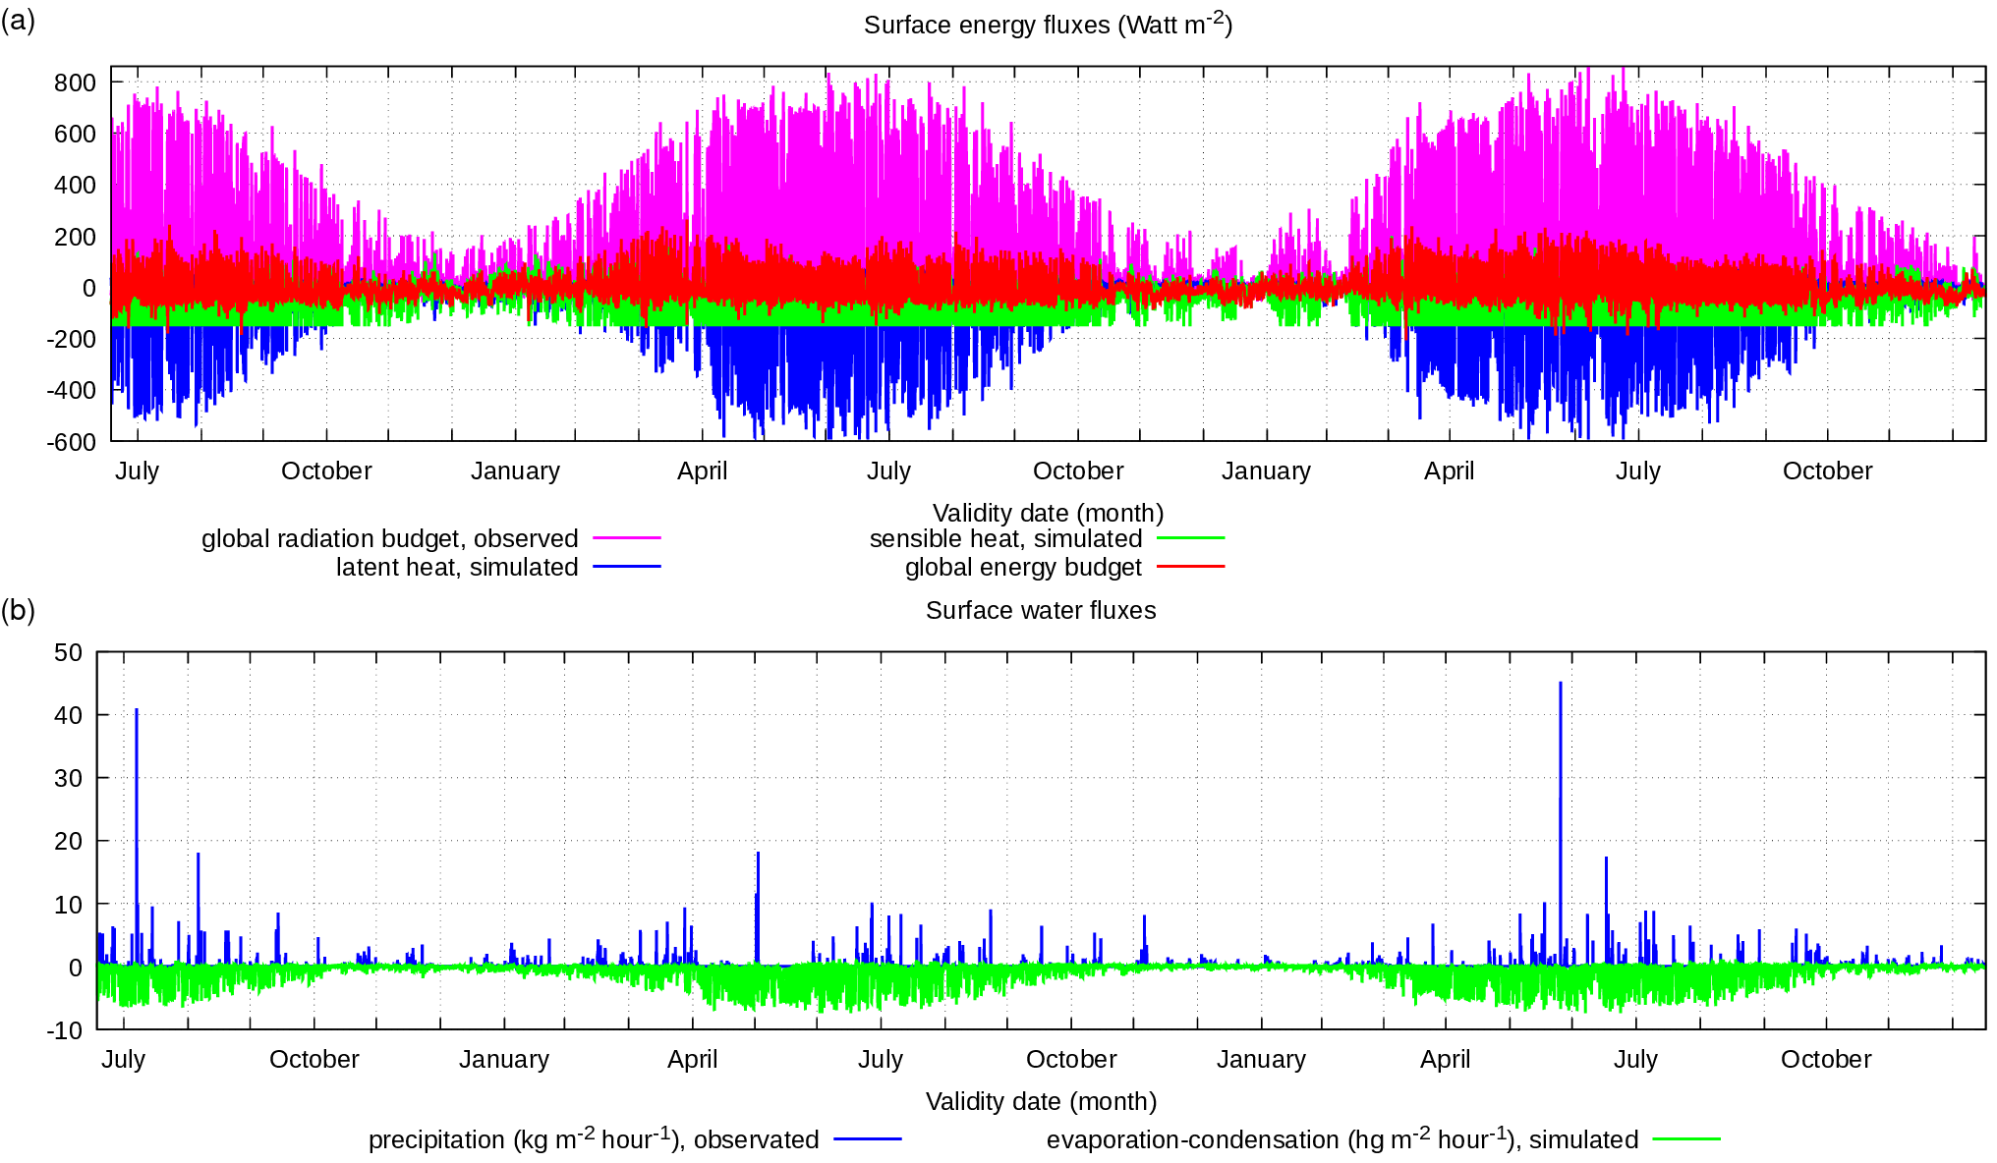
Figure A7. Simulation and observation data for the period 3 July 2007 – 31 December 2009, parameters at the surface: (a) solar radiation (W m⁻²) observed and heat fluxes (W m⁻²) simulated; (b) precipitation rate (kg m⁻² hour⁻¹) observed and evaporation rate (hg m⁻² hour⁻¹) simulated.

Figure A8. Simulated and observed soil temperature (°C) at the surface and at various depths: (a) surface; (b) -0.05 m; (c) -0.15 m; (d) -0.60 m for the period 3 July 2007 – 31 December 2009.

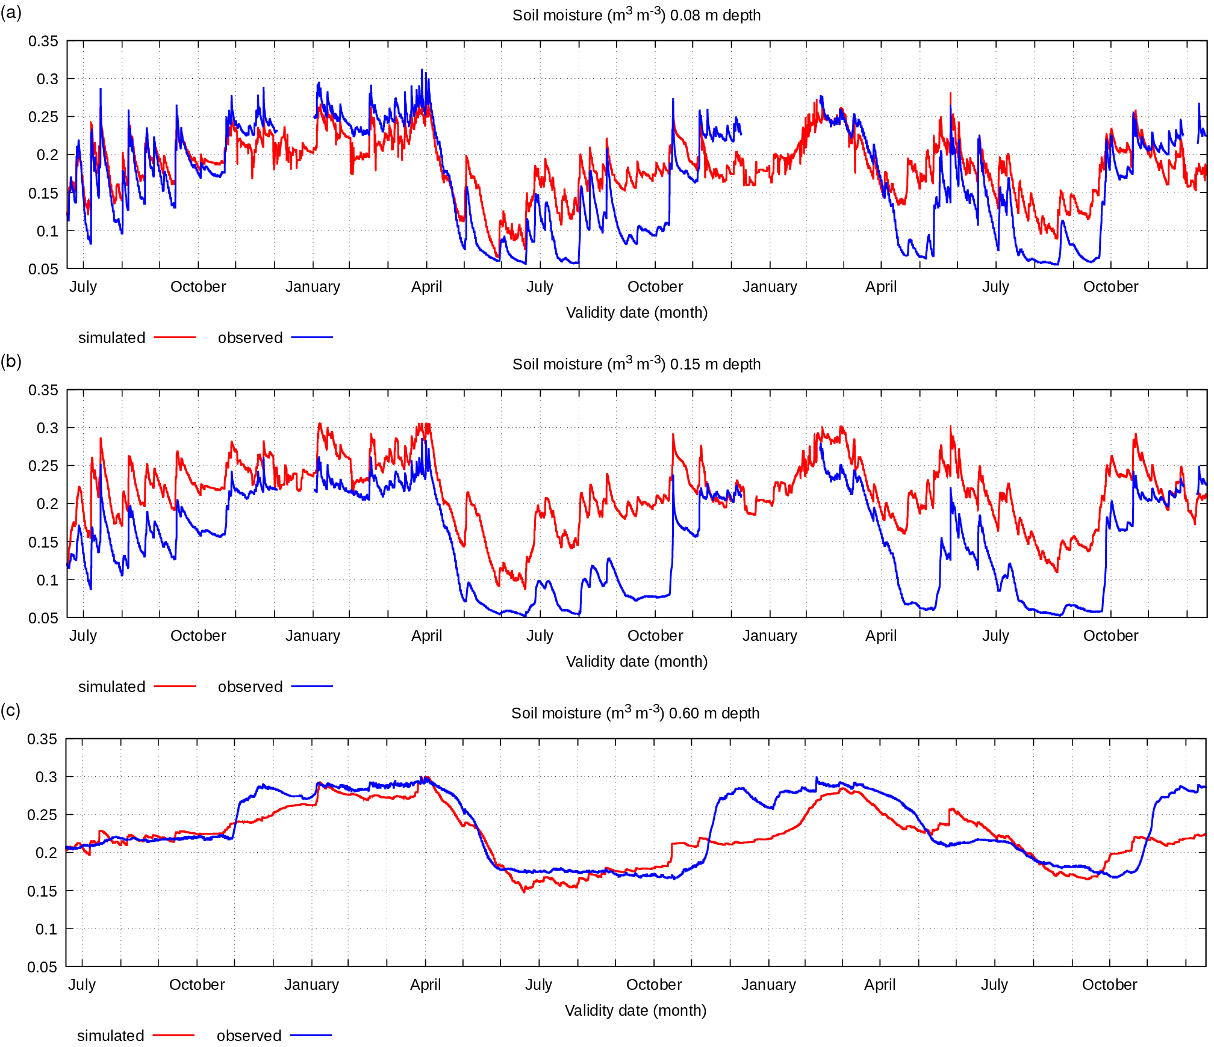
Figure A9. Simulated and observed soil specific volumetric water content (m3 m-3) at various depths: (a) -0.08 m; (b) -0.15 m; (c) -0.60 m for the period 3 July 2007 – 31 December 2009.

Figures A7-A9 show a well-defined seasonal cycle of the surface and soil parameters. Periods with very hot and with very cold weather, as well as periods with precipitation, are present in the observed data. As it can be seen in figures A8 and A9, unfortunately, at temperatures below 0°C, the soil temperature and soil water content sensors did not operate in both winters. However, the surface temperature sensor operated during the whole simulation period.
Figures A8 and A9 show that the simulated values for different parameters are close to observed values. The surface temperature is very close to observed values (fig. A8a), this means that Pochva and the air surface layer schemes approximate very well the energy flux surface equilibrium. This is very important because the main task of the Pochva scheme is to correctly simulate the thermal state of the surface for use in a numerical atmosphere model. The simulation of soil temperature at middle levels has some problems with underestimation (by 3-5 degrees) in the summer months (fig. A8b, A8c), this error is also noticeable in the deep layer (fig. A8d), but less pronounced (2-3 degrees). During winter months, when the surface temperature is mostly between 0 and -20 °C, the simulation of soil temperature is correct at all soil levels. The soil water content at upper layer is simulated mostly correctly (fig. A9a), with the exception of August 2008 and 2009 and October 2008 and 2009 when soil moisture at 8 cm depth was overestimated. At the same time, soil water content in the deeper layer was simulated correctly (fig. A9c).
To summarise, it can be noted that Pochva scheme simulates correctly the temperature and water content of the soil in the upper and lower soil layers at any season of the year, but in the middle layer only in cold season, and in warm season underestimates the temperature of this layer and overestimates the water content.

